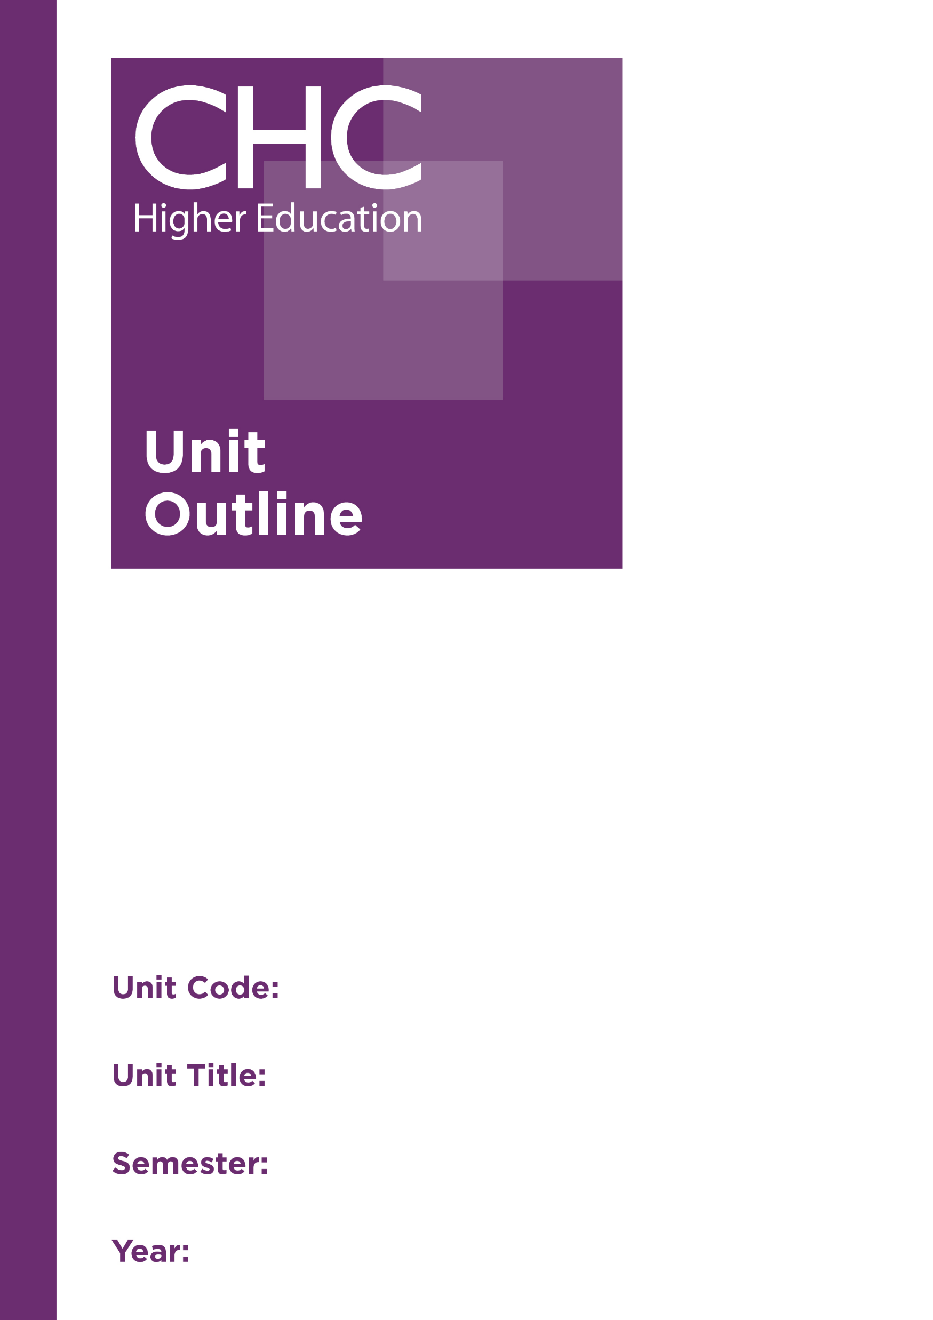
Unit Code: FR540

Unit Title: Family and Relationship
Counselling: Theoretical Foundations

Semester: 1

Year: 2020

Unit code | FR540
Unit name | Family and Relationship Counselling: Theoretical Foundations
Associated higher education awards | Master of Counselling
Duration | One semester
Level | Postgraduate
Unit coordinator | Neil Roberts
Core/elective | Elective
Weighting | Unit credit points: 10  Course credit points: 160
Delivery mode | Face-to-face on site  External
Student workload | Face-to-face on site  Contact hours 35 hours  Reading, study, and preparation 55 hours  Assignment preparation 60 hours  TOTAL 150 hours  External  Engagement with study materials 90 hours  Assignment preparation 60 hours  TOTAL 150 hours
 | Students requiring additional English language support are expected to undertake an additional one hour per week.
Prerequisites/ co-requisites/ restrictions | Nil
Rationale | Many of the issues that encourage people to seek the help of a professional counsellor arise from their primary relationships. Dealing with relationship issues is most effective when all persons involved are present; consequently, family and relationship counsellors often work with two or more family members together.  In order to equip professional practitioners for appropriate interventions in the area of family and relationship counselling, a number of theories and perspectives that are relevant to family and relationship counselling need to be considered. The aim of this unit is, therefore, to ensure students have a sound knowledge and understanding of these theories and perspectives, and the ability to critique approaches to family and relationship counselling from a process-based framework and from a Christian worldview perspective. The unit will also give students the opportunity to apply these theories and perspectives to their own family experiences and the experiences of other families.
Prescribed text(s) | Capuzzi, D., & Stauffer, M. (Eds.). (2015). Foundations of couples, marriage and family counseling. Hoboken, NJ: Wiley.
Recommended readings | Books  Balswick, J. & Balswick, J. (2014). The family: A Christian perspective on the contemporary home (4th ed.). Grand Rapids, MI: Baker Academic.  Conger, R., Lorenz, F., & Wickrama, K. (Eds.). (2014). Continuity and change in family relations: Theory, methods and empirical findings. New York, NY: Psychology Press.  Goldenberg, H., & Goldenberg, I. (2013). Family therapy: An overview (8th ed.). Belmont, CA: Brooks/Cole.  Hughes, D. (2007). Attachment-focused family therapy. New York, NY: Norton.  McGoldrick, M., Carter, B., & Garcia-Preto, N. (Eds.). (2011). The expanded family life cycle: Individual, family and social perspectives (4th ed.). Boston, MA: Allyn and Bacon.  Nichols, M. P., & Schwartz, R. C. (2013). Family therapy: Concepts and methods (10th ed.). Boston, MA: Pearson.  Peterson, C. (2013). Looking forward through the lifespan: Developmental psychology (6th ed.). Sydney, Australia: Pearson.  Rasheed, J., Rasheed, M., & Marley, J. A. (2011). Family therapy: Models and techniques. Los Angeles, CA: Sage.  Journals and Periodicals  Family Process  Journal of Marital and Family Therapy  Journal of Marriage and Family  Journal of Psychology and Theology  In addition to the resources above, students should have access to a Bible, preferably a modern translation such as The Holy Bible: The New International Version 2011 (NIV 2011) or The Holy Bible: New King James Version (NKJV).  These and other translations may be accessed free on-line at http://www.biblegateway.com. The Bible app from LifeChurch.tv is also available free for smart phones and tablet devices.
Specialist resource requirements | Nil
Content | - Understanding the family system from biblical, psychological and sociological perspectives  - Stages of family development  - Family and relationship diversity in the 21st century  - The family within the broader sociocultural context  - What brings families to therapy?  - Critiquing models of family and relationship counselling:  - Family systems models  - Experiential family therapy  - Attachment-based therapies  - Constructivist approaches
Learning outcomes | On completion of this unit, students will have demonstrated that they have:  - exhibited an advanced understanding of concepts and theories relevant to family and relationship functioning;  - critically reflected on the functioning of their own family, drawing on relevant family and relationship theories;  - critically examined a number of perspectives on the family, including sociological, multicultural and Christian worldview perspectives in relation to family and relationship counselling;  - evaluated approaches to family and relationship counselling from evidence-based, practice-based, and Christian worldview perspectives;  - synthesised their knowledge into a coherent and holistic understanding of family functioning and experience; and  - communicated at an appropriate tertiary standard with special attention to correct grammars, punctuation, spelling, vocabulary, usage, sentence structure, logical relations, style, referencing, and presentation.
Assessment tasks | Task 1: Autobiographical case study  Reflect on your family of origin experience and analyse the family’s functioning using theories studied in this unit.  Word Length/Duration: 1,500 words  Weighting: 30%  Learning Outcomes: 1-3, 6  Assessed: Week 6  Task 2: Literature Review  Present a review of literature on one approach to family therapy to the class for discussion.  Word Length/Duration: 2,500 words  Weighting: 40%  Learning Outcomes: 1, 3, 4, 6  Assessed: Week 11  Task 3: Concept map  Develop a concept map incorporating the theoretical concepts from this unit that you intend to incorporate into your framework for conceptualising and working with families and relationships.  Word Length/Duration: 1,500 words (equivalent)  Weighting: 30%  Learning Outcomes: 1-6  Assessed: Week 15
Unit summary | The aim of this unit is to ensure students have a sound knowledge and understanding of the theories and perspectives that are relevant to family and relationship counselling, and the ability to both critique and apply those theories and perspectives to their own family experiences and the experiences of other families.

