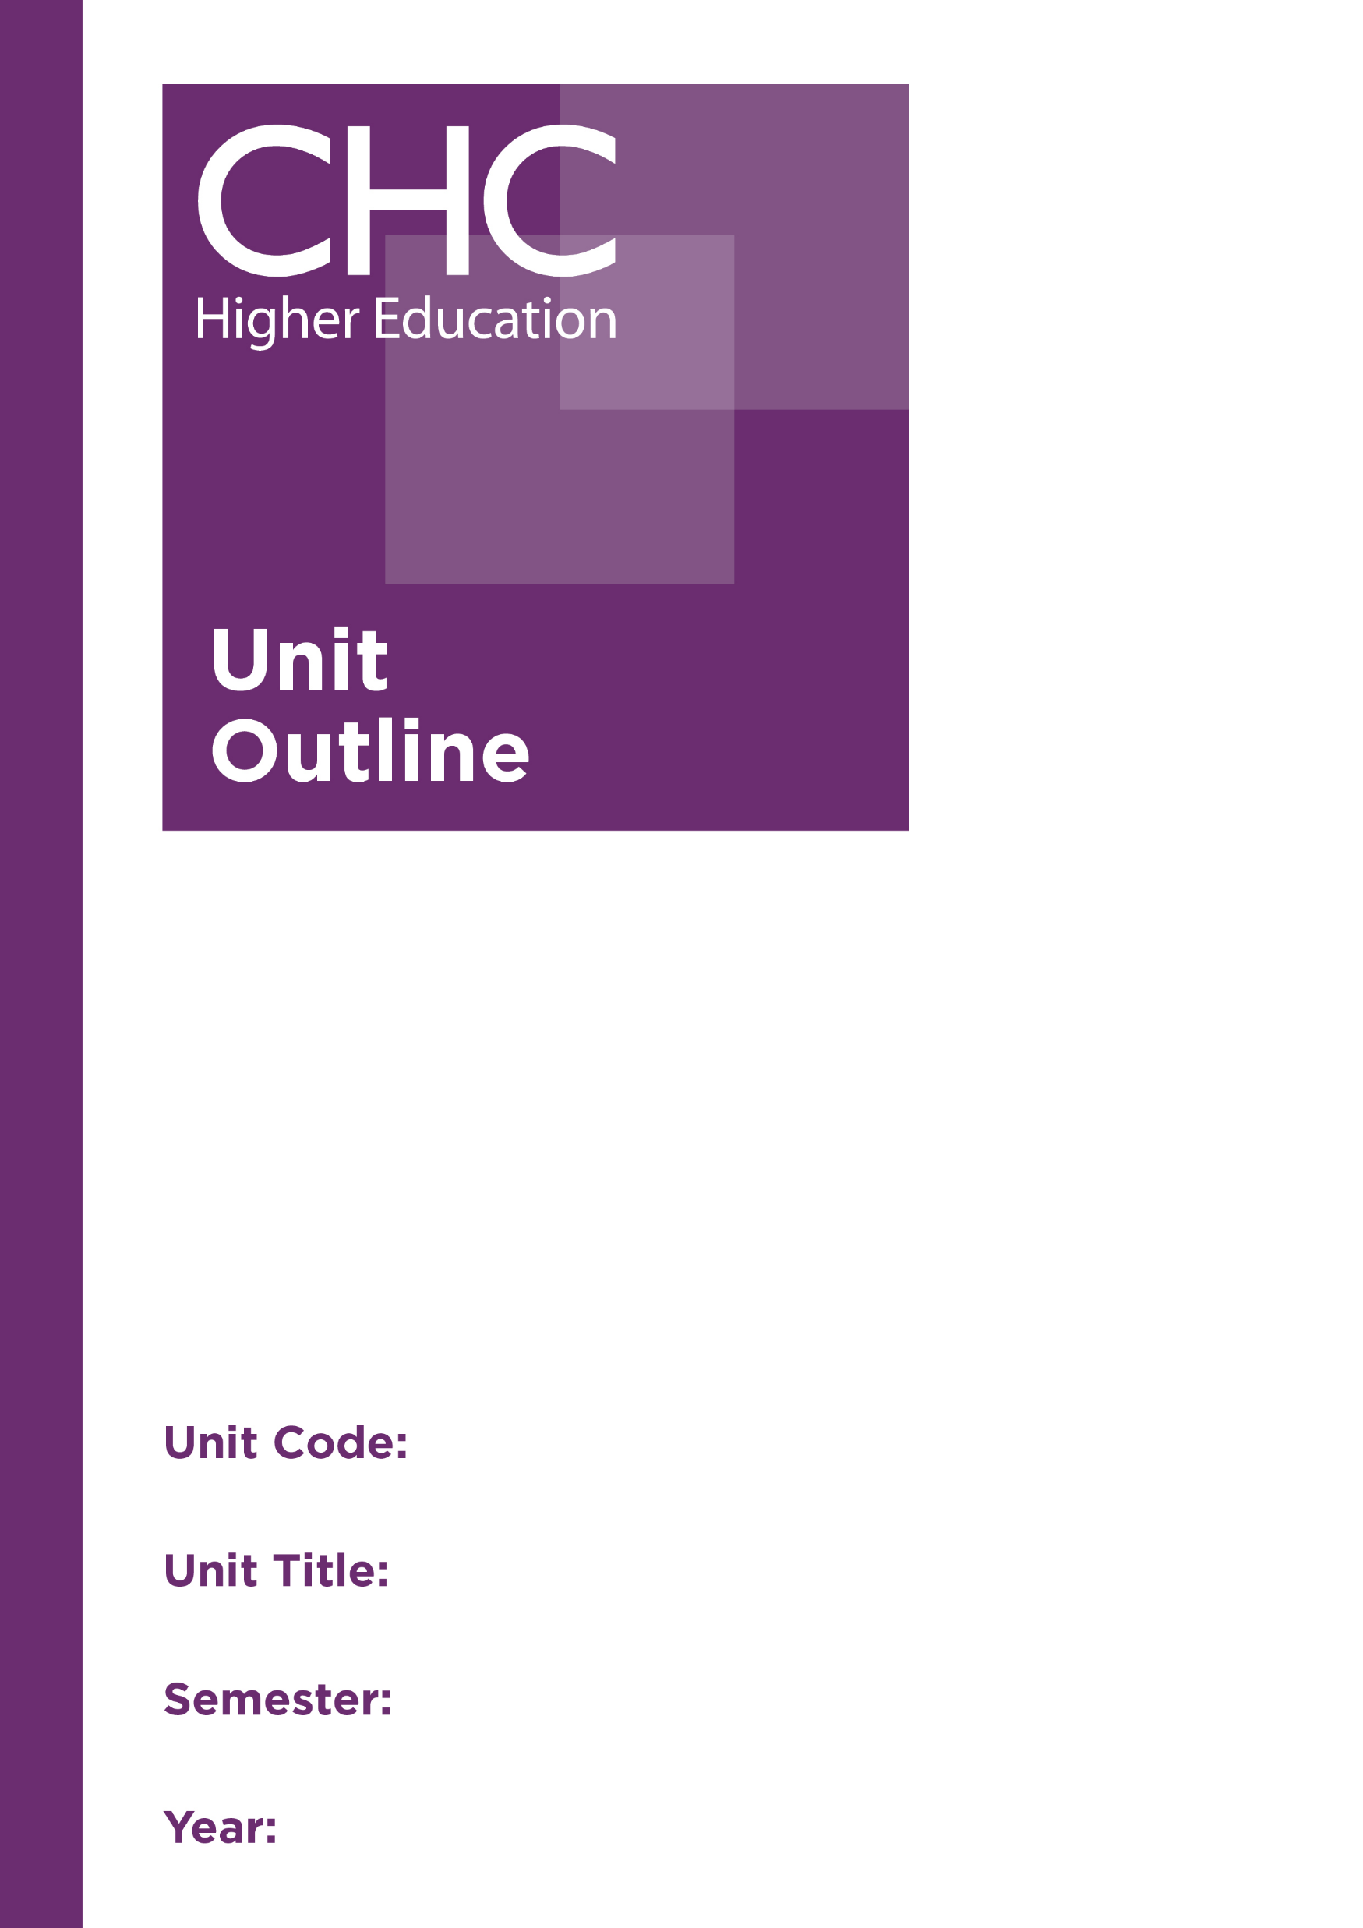
Unit Code: FR541

Unit Title: Family and Relationship
Counselling: Intervention Frameworks

Semester: 1

Year: 2020

Unit code | FR541
Unit name | Family and Relationship Counselling: Intervention Frameworks
Associated higher education awards | Master of Counselling
Duration | One semester
Level | Postgraduate
Unit coordinator | Peter Janetzki
Core/elective | Elective
Weighting | Unit credit points: 10  Course credit points: 160
Delivery mode | Face-to-face on site
Student workload | Face-to-face on site  Contact hours 35 hours  Reading, study, and preparation 55 hours  Assignment preparation 60 hours  TOTAL 150 hours
 | Students requiring additional English language support are expected to undertake an additional one hour per week.
Prerequisites/ co-requisites/ restrictions | Prerequisite or co-requisite  FR540 Family and Relationship Counselling: Theoretical Foundations  CO614 Processes and Strategies
Rationale | Working with families and relationships requires a more specialised skill set than that required for general counselling. To be able to provide effective family and relationship counselling, counsellors need skills and strategies for working with the dynamics of having multiple clients in the room, based on a thorough understanding of the interplay of ‘system dynamics’ at work in such a setting.  The aim of this unit is to introduce students to a range of specific skills for conceptualising and working with the system dynamics of family and relationship counselling in order to develop a process-based framework for intervention. As the life partners are considered to be the foundation on which the family is established (Balswick & Balswick, 2007; Satir, 1983), the emphasis in this unit will be on working with the couple dyad in order to promote enhanced functioning within the family.  Students will engage with the content through a reflective practice framework, integrating theory, issues and skills, including relevant Christian worldview, cultural and ethical perspectives.
Prescribed text(s) | Balswick, J., & Balswick, J. (2014). The family: A Christian perspective on the contemporary home (4th ed.). Grand Rapids, MI: Baker Academic.  Gottman, J. & Gottman, J. S. (2015). 10 Principles for doing effective couples therapy. New York, NY: Norton.
Recommended readings | Books  Bader, E., & Pearson, P. (2013). In quest of the mythical mate: A developmental approach to diagnosis and treatment in couples therapy. New York, NY: Brunner/Mazel.  Carson, D., & Casado-Keho, M. (Eds.). (2011). Case studies in couples therapy: Theory-based approaches. New York, NY: Routledge.  Lerner, H. (1989). The Dance of intimacy: A woman’s guide to courageous acts of change in key relationships. New York, NY: HarperRow.  McGoldrick, M., Gerson, R., & Petry, S. (2008).¹ Genograms: Assessment and intervention (3rd ed.). New York, NY: Norton.  Nichols, M. P. & Schwartz, R. C. (2013). Family therapy: Concepts and methods (10th ed.). Boston, MA: Pearson.  Payne, M. (2010). Couple counselling: A practical guide. London, UK: Sage.  Rasheed, J., Rasheed, M., & Marley, J. A. (2011). Family therapy: Models and techniques. Los Angeles: Sage.  Rhodes, P., & Wallis, A. (2011). Practical guide to family therapy: Structured guidelines and key skills. Melbourne, Australia: IP Communications.  Solomon, M., & Tatkin, S. (2011). Love and war in intimate relationships: Connection, disconnection, and mutual regulation in couple therapy. New York, NY: Norton.  Wilcoxon, S.A. (2007). Ethical, legal and professional issues in the practice of marriage and family therapy. Upper Saddle River, NJ: Pearson.  Journals and Periodicals  Family Process  Journal of Marital and Family Therapy  Journal of Marriage and Family  Journal of Psychology  In addition to the resources above, students should have access to a Bible, preferably a modern translation such as The Holy Bible: The New International Version 2011 (NIV 2011) or The Holy Bible: New King James Version (NKJV).  These and other translations may be accessed free on-line at http://www.biblegateway.com. The Bible app from LifeChurch.tv is also available free for smart phones and tablet devices.
Specialist resource requirements | Digital recording device
Content | - The person of the family and relationship therapist and use of self  - Therapeutic dynamics with two or more people in the room  - Building and maintaining balanced therapeutic alliances  - Emotional regulation and the neuroscience of relationships  - Case conceptualisation  - Working with process vs. content  - Common issues in family relationships  - Interventions with the couple dyad  - Challenges for the therapist- managing transference and counter-transference, parallel process, differentiation, supervision  - Ethical issues in family and relationship counselling
Learning outcomes | On completion of this unit, students will have demonstrated that they have:  - exhibited an understanding of the multiple dynamics involved in family and relationship counselling;  - identified and analysed common issues and themes in family and relationship counselling and applied appropriate interventions;  - developed skills and strategies for working with a couple dyad on common family and relationship issues within an integrated process-based framework;  - evaluated their own use of family and relationship counselling skills;  - critically reflected on the role of the therapist and the therapist’s use of self in family and relationship counselling;  - critically analysed the multicultural, Christian worldview, and ethical issues involved in working with families and relationships; and  - communicated at an appropriate tertiary standard with special attention to correct grammars, punctuation, spelling, vocabulary, usage, sentence structure, logical relations, style, referencing, and presentation.
Assessment tasks | Task 2: Participation in case discussions  Participate in regular discussions about client cases, demonstrating the ability to provide multi-faceted case formulations from process-based, cultural, ethical and Christian worldview perspectives.  Word Length/Duration: 3 x 60 minutes  Weighting: Pass/Fail  Learning Outcomes: 1-2, 5, 6  Assessed: Throughout the semester  Task 2: Forum posts and reflective essay  Part A: Contribute to a forum throughout the semester reflecting on your learning from the class, case discussion sessions, readings and considerations on your use of self (as well as your own family of origin experience).  Part B: Synthesise your learning from the semester with regard to you as a relationship counsellor, including how you intend to address specific challenges for you in your work.  Word Length/Duration: Forum posts - minimum 5 x 200 words; Essay - 1,500 words  Weighting: Forum posts - Formative; Essay - 30%  Learning Outcomes: 1, 2, 4-7  Assessed: Forum posts - Week 2 – 13; Essay - Week 15  Task 3: Video and process report  Record a relationship counselling session demonstrating your ability to work with a couple dyad to address a relationship issue. A process report is then to be written conceptualising the issues presented in the session and analysing the effectiveness of the session.  Word Length/Duration: Video - 60 minutes; Process Report - 2,000 words  Weighting: Video: 30%; Process Report: 40%  Learning Outcomes: 1-7  Assessed: Week 13
Unit summary | This unit introduces students to a range of specific skills for conceptualising and working with the system dynamics of family and relationship counselling in order to develop a process-based framework for intervention. Students will learn a range of specific family and relationship focused counselling skills that will enable them to deal effectively with those who present for family and relationship counselling. Interventions will focus on working with the couple dyad to promote change.

Seminal text.

