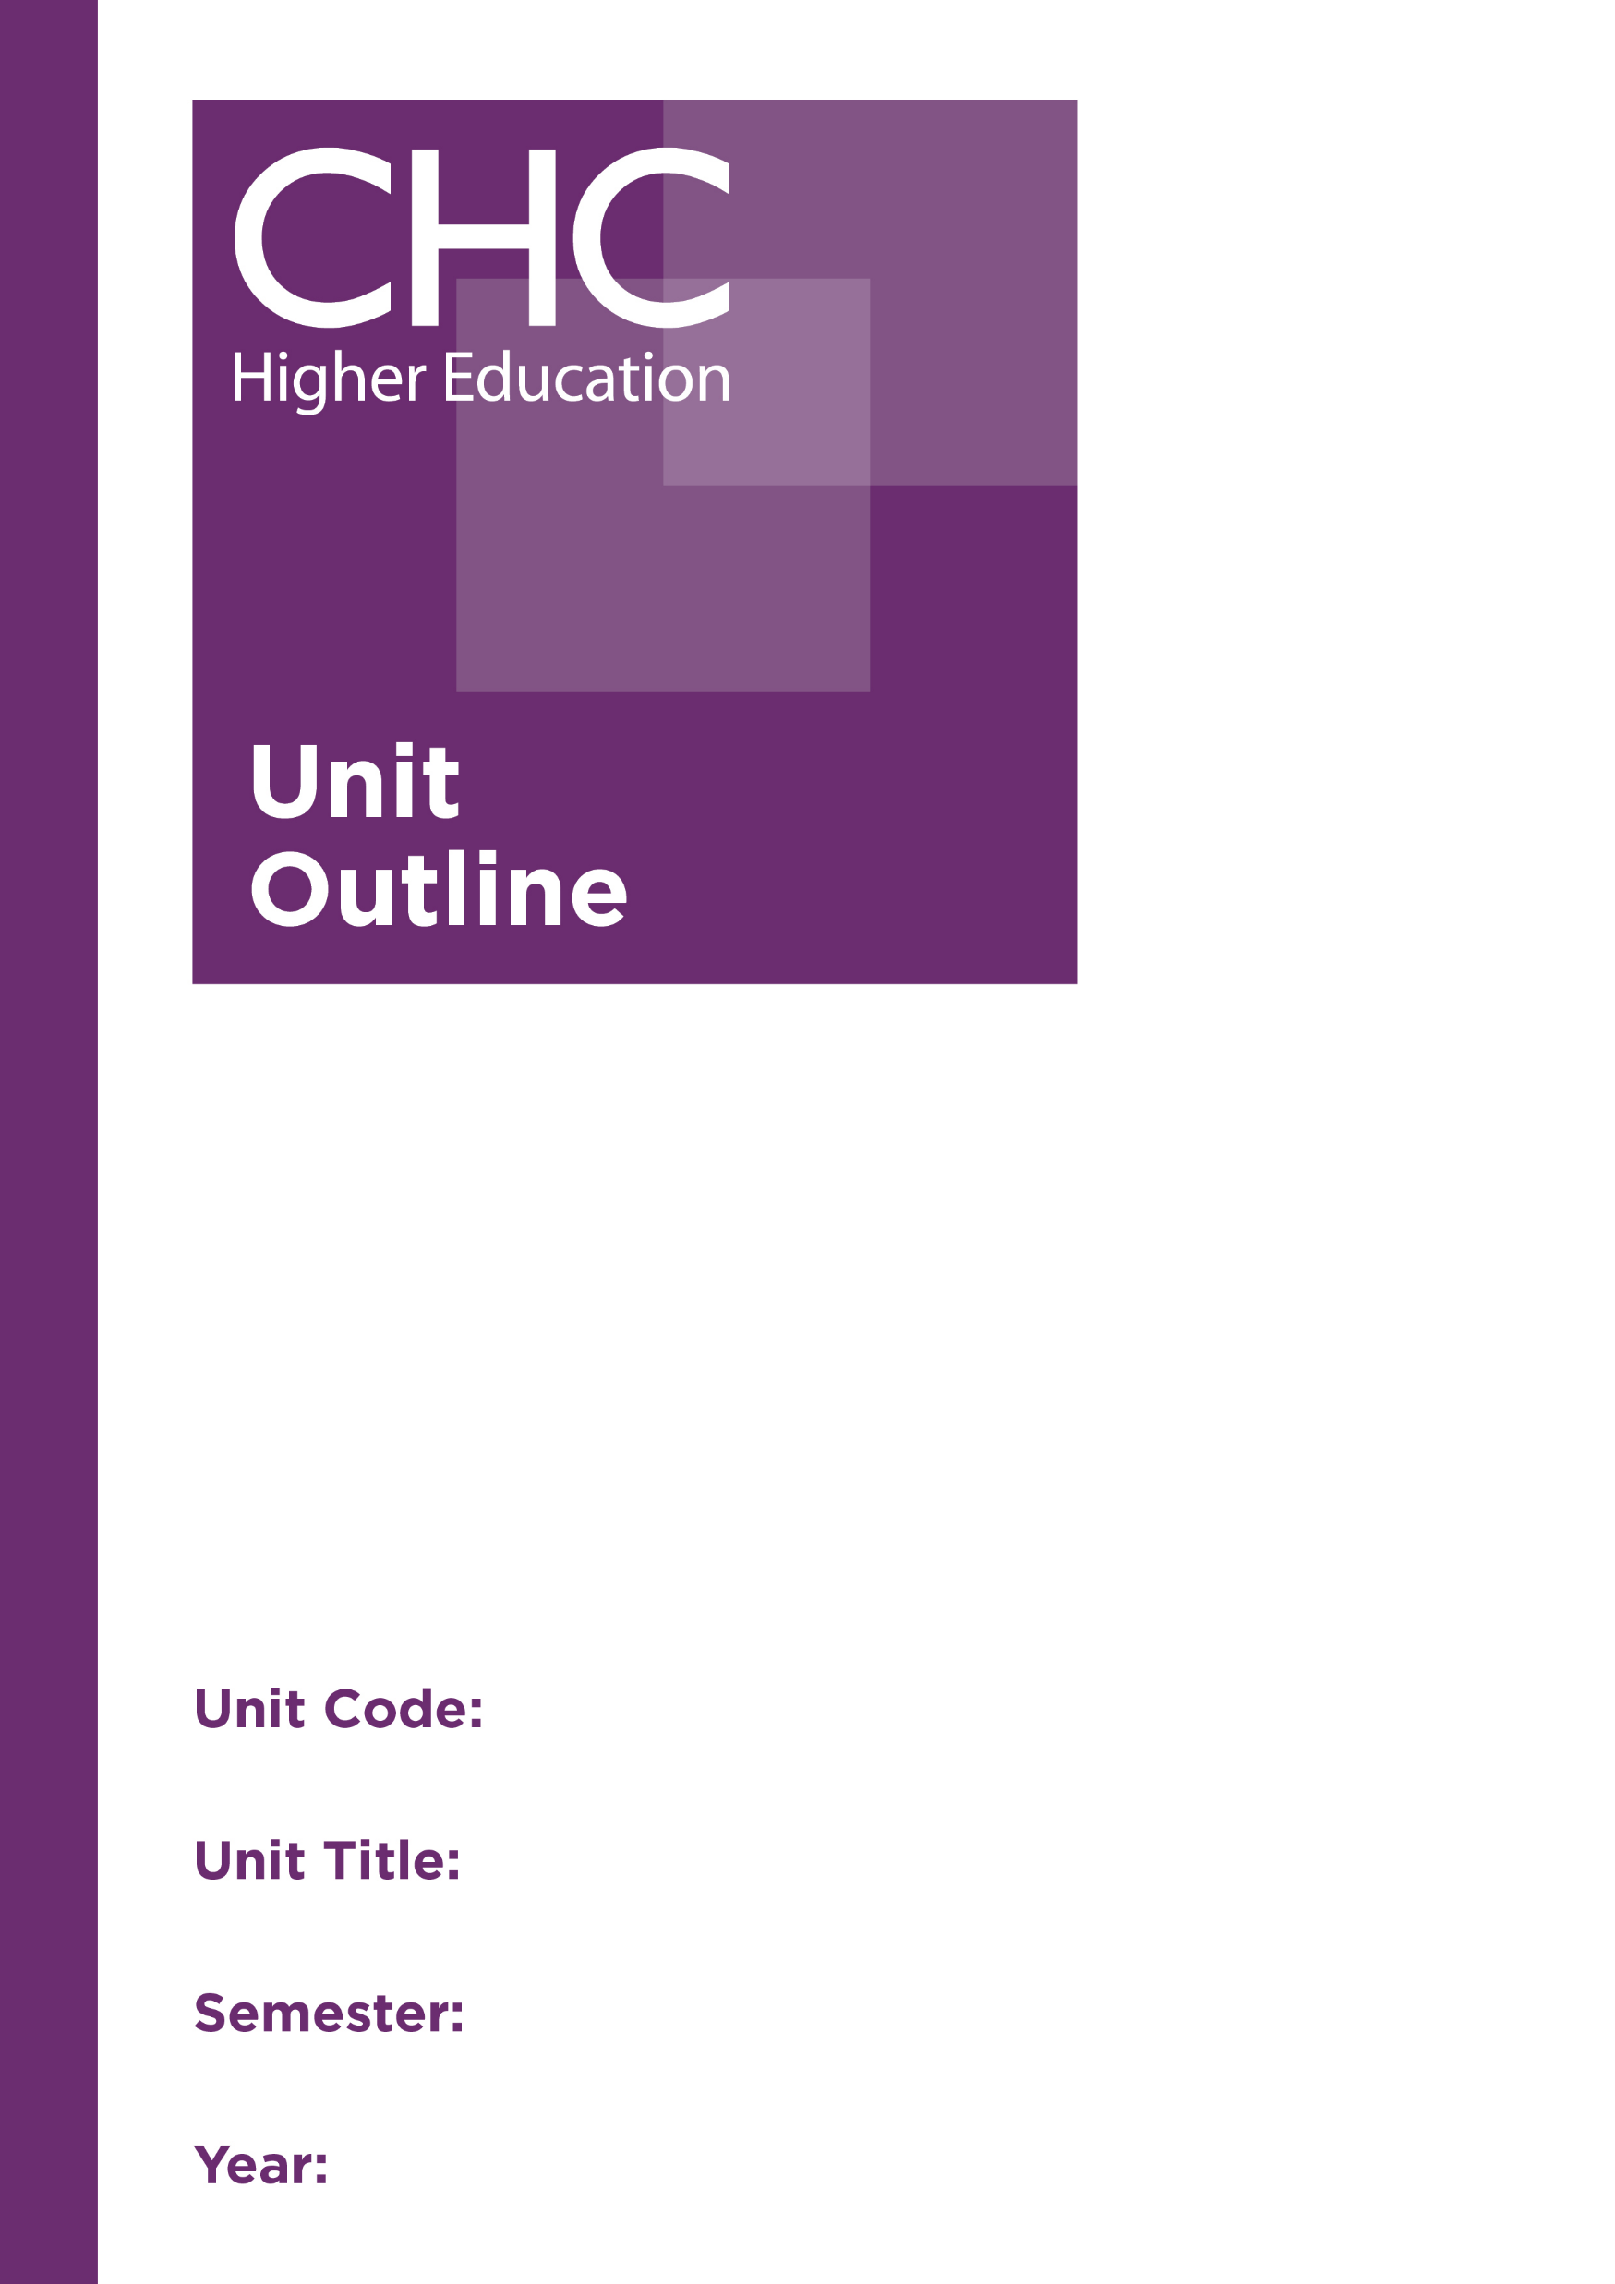
Family and Relationship Counselling: Intervention Strategies
2019

2

FR542

Unit code | FR542
Unit name | Family and Relationship Counselling: Intervention Strategies
Associated higher education awards | Graduate Certificate in Counselling Practice  Master of Counselling Practice  Master of Counselling
Duration | One semester
Level | Postgraduate
Unit Coordinator | Neil Roberts
Core/elective | Elective
Weighting | Unit credit points: 10  Course credit points: Graduate Certificate in Counselling Practice 80  Master of Counselling Practice 120  Master of Counselling 160
Delivery mode | Face-to-face on site
Student workload | Face-to-face on site  Contact hours 35 hours  Reading, study, and preparation 55 hours  Assignment preparation 60 hours  TOTAL 150 hours
 | Students requiring additional English language support are expected to undertake an additional one hour per week.
Prerequisites/ co-requisites/ restrictions | Prerequisite  FR541 Family and Relationship Counselling: Intervention Frameworks  Pre or corequisite  CO667 Reflective Practice: Consolidating Foundations
Rationale | Due to a range of factors, some families present with more complex issues than others. Family and relationship counsellors need an awareness of the dynamics involved in these issues and specific skills to help the families affected. This unit focuses on applying focused intervention strategies to specific presenting issues in family and relationship counselling.  In particular, this unit aims to give students an understanding of the dynamics involved in the breakdown of the family unit, and skills to help families navigate through these challenges. Ethical and legal implications, as well as a Christian worldview perspective, will be considered. Other issues that cause stress for contemporary families, and strategies for supporting them, will also be considered.
Prescribed text(s) | Capuzzi, D., & Stauffer, M. (Eds.). (2015). Foundations of couples, marriage and family counseling. Hoboken, NJ: Wiley.
Recommended readings | Books  Balswick, J., & Balswick, J. (2008). Authentic human sexuality: An integrated Christian approach (2nd ed.). Downers Grove, IL: InterVarsity Press.¹  Caselman, T., & Hill, H. (2014). Working therapeutically with families: Creative activities for diverse family structures. London, UK: Jessica Kingsley.  Emery, R. (2012). Renegotiating family relationships: Divorce, child custody and mediation (2nd ed.). New York, NY: Guilford.  Laurel, K. (2015). Strengthening family coping resources: Interventions for families impacted by trauma. New York, NY: Routledge.  Patterson, J., Williams, L., Edwards, T., Chamow, L., & Grauf-Grounds, C. (2009). Essential skills in family therapy: From the first interview to termination (2nd ed.) New York, NY: Guilford.  Rasheed, J., Rasheed, M., & Marley, J. A. (2011). Family therapy: Models and techniques. Los Angeles: Sage.  Rhodes, P., & Wallis, A. (2011). Practical guide to family therapy: Structured guidelines and key skills. Melbourne, Australia: IP Communications.  Schnarch, D. (2009). Intimacy and desire: Awaken the passion in your relationship. New York, NY: Beaufort Books.¹  Smoke, J. (1995). Growing through divorce (Rev. ed.). Eugene, OR: Harvest House.  Journals and Periodicals  Family Process  Journal of Marital and Family Therapy  Journal of Marriage and Family  Journal of Psychology  In addition to the resources above, students should have access to a Bible, preferably a modern translation such as The Holy Bible: The New International Version 2011 (NIV 2011) or The Holy Bible: New King James Version (NKJV).  These and other translations may be accessed free on-line at http://www.biblegateway.com. The Bible app from LifeChurch.tv is also available free for smart phones and tablet devices.
Specialist resource requirements | Nil
Content | - Working with the whole family  - Sexuality and sexual dynamics in relationships  - Health issues in families (including chronic illness, mental health, addictions)  - Interventions for helping families through divorce and separation  - Risk assessments and management; ethical and legal issues  - Working with domestic and family violence  - Challenges for contemporary families (eg Clergy, 3rd culture kids, military, fly in/fly out families, blended families)  - Developing an integrated framework for practice
Learning outcomes | On completion of this unit, students will have demonstrated that they have:  - exhibited an advanced understanding of the issues that increase stress in families and add complexity to family and relationship counselling;  - critically analysed, and applied evidenced-based interventions for working with specific issues in family and relationship counselling;  - critically examined the ethical, legal, and Christian worldview issues involved in family and relationship counselling, and considered appropriate strategies for assessing and managing risk;  - refined relationship counselling skills and strategies within a process-based framework;  - developed and reflected on skills for working with specific family and relationship issues;  - synthesised their knowledge and understanding of theory, issues and skills for working with families and relationships; and  - communicated at an appropriate tertiary standard with special attention to correct grammars, punctuation, spelling, vocabulary, usage, sentence structure, logical relations, style, referencing, and presentation.
Assessment tasks | Task 1: Engagement in class discussion and activities  You are to actively participate in class discussions and activities throughout the semester, demonstrating engagement with the course materials.  Word Length/Duration: N/A  Weighting: 10%  Learning Outcomes: 1-4  Assessed: Weeks 1-13  Task 2: Research essay  Research one theoretical approach/intervention for working with one of the issues discussed in this unit, including the evidence-base for this approach, ethical, legal and Christian worldview considerations.  Word Length/Duration: 2,500 words  Weighting: 40%  Learning Outcomes: 1-3, 7  Assessed: Week 10  Task 3: Case study report  Write up a case study of your work with a family you have been working with on your practicum, demonstrating your ability to work with two or more members of a family on one of the relationship issues studied in this unit. The report is to include a case formulation, a description of the therapeutic approach and interventions you have used with the family, a consideration of the worldview and ethical and/or legal issues inherent in the case, and a reflection on the progress of your work with this family.  Word Length/Duration: 3,000 words  Weighting: 50%  Learning Outcomes: 1-7  Assessed: Week 15
Unit summary | This unit focuses on applying focused intervention strategies to specific presenting issues in family and relationship counselling. In particular, this unit aims to give students an understanding of the dynamics involved in the breakdown of the family unit, and skills to help families navigate through these challenges. Ethical and legal implications, as well as a Christian worldview perspective, will be considered. Other issues that cause stress for contemporary families, and strategies for supporting them, will also be considered.

Seminal text.

