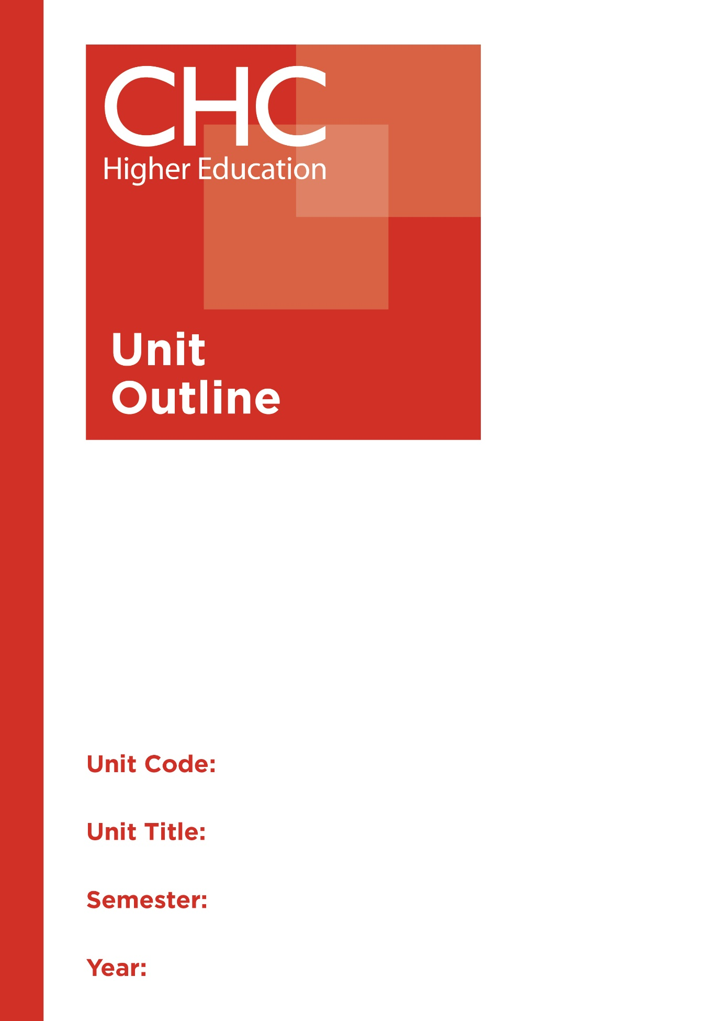

HP100
Introduction to Health & Physical Education
1

Unit code | HP100
Unit name | Introduction to Physical Education
Associated higher education awards | Bachelor of Education (Secondary)  Bachelor of Arts/Bachelor of Education (Secondary)
Duration | One Semester
Level | Introductory
Unit coordinator | Debra Ayling
Core/elective | Elective
Weighting | Unit credit points: 10  Course credit points: 320 - Bachelor of Education (Secondary)  320 - Bachelor of Arts/Bachelor of Education (Secondary)
Delivery mode | Face-to-face
Student workload | Contact hours/Directed Study 30 hours  Reading, study, preparation 50 hours  Assignment preparation 70 hours  TOTAL 150 hours
 | Students requiring additional English language support are expected to undertake an additional one hour per week.
Prerequisites/ co-requisites/ restrictions | Nil.
Rationale | Enduring Understanding:  The ‘cult of slenderness’, physical elitism, poor dietary practices and a lifestyle of stress all reflect a common modern lack of understanding of a healthy and whole person. Christian orthodoxy has always advocated practices, which encourage health in all dimensions of being, and this includes the body. It is important for students to develop philosophical and practical perspective on human health and movement practices to undergird a study of health, movement theories, psychomotor development, games and associated pedagogy.  This unit recognises the need to educate students in practices and principles of healthy living. It will address issues of general health and human movement, and will establish the philosophical grounds for health practices through a focus both on the theory of health and physical education. Students will develop skills in health and movement practices as well as curriculum development and evaluation in Health and Physical Education (HPE)to enable them to develop teaching practices for effectively engaging school students in health and human movement skills.
Learning delivery process | Interactive engagement through on-campus or online learning modes with full access to CHC’s learning portal of resources:  On-Campus mode  - Weekly lecture.  - Weekly tutorial (where applicable).  Plus, CHC learning portal resources (see below).  On-line mode  - CHC learning portal (Moodle™) including:  - Synchronous and asynchronous virtual lectures  (multi-user collaborative learning interfaces, lecture capture, interactive Power Point presentation and resources)  - lecture capture recordings bank  - weekly readings;  - learning guides;  - assessment guides  - Collaborative forums: Student forums and News forum.  - Turnitin assessment and feedback tool.  All unit outlines are reviewed prior to the offering of the unit to take account of student and lecturer feedback.
Content | 1. Foundations of Teaching and Learning Movement Skills in Physical Education.  2. Foundations of Teaching and Learning Health.  3. Pedagogies and Practices for HPE.  4. Work Health and Safety for HPE.  5. Teaching Inclusively in HPE: Diversity and Equality.  6. Weekly Physical Education and Health Experiences (Including Core games, Aquatics, Athletics, Gymnastics and Dance).
Learning Outcomes | On completion of this unit, pre-service teachers will have provided evidence that they have:  1. demonstrated knowledge of philosophical and practical perspectives on human health and movement practices within the discipline of HPE;  Graduate Attributes: 1,2,4,5  2. engaged with a development of movement skills and an awareness of health consciousness;  Graduate Attributes: 1,2,4,5  3. reflected upon a Christian perspective in relation to the human body and HPE imperatives;  Graduate Attributes: 1,2,3,4,5,7  4. applied the theory of health and physical education to prepare learning experiences using state and/or national curriculum documentation for the health and physical education learning area;  Graduate Attributes: 1,2,4,5  5. employed appropriate pedagogical skills and strategies for planning learning experiences and assessing school students’ demonstrations in HPE; and  Graduate Attributes: 1,2,4,5  6. communicated at an appropriate tertiary standard: with special attention to design elements, grammars, usage, logical relations, style, referencing and presentation.  Graduate Attributes: 6
Assessment tasks | Task 1: Demonstration  Physical Activity Presentation  Word Length/Duration: 15 minutes  Weighting: 40%  Assessed: Weeks 5-7  Task 2: Reflections  Reflective Observations and Essay  Word Length/Duration: 2,000 words  Weighting: 60%  Assessed: Week 14
Assessment alignment | Assessment Task Learning Outcome Content Graduate Teacher Standards  Task 1 1,2,4-6 1-6 2.1  Task 2 1,3,5-6 1-6 2.1
Prescribed text(s) | Callcott, D., Miller, J., & Wilson-Gahan, S. (2012). Health and physical education: Preparing educators for the future. Melbourne, VIC: Cambridge University Press.  Selected readings will be available via the Moodle™ site for this unit.
Recommended readings | Curriculum Readings  Athletics Australia. Curriculum outcomes 2002, Author, Melbourne.  Austin, J. & Hickey, A. (Eds.). (2007). Education for healthy communities: possibilities through SOSE and HPE. Frenchs Forest, NSW: Pearson Education Australia.  Boyd, A., Bultitude, S. & Wright, J. (2006). Exploring physical activity and sport. Gymea, NSW: Titan Education.  Clarke, D. (2008) Move into PASS. South Yarra, VIC: Macmillan Education Australia.  Darst, P. W., Pangrazi, B., Brusseau, T. & Erwin, H. (2014). Dynamic physical education for secondary school students. 8th Edition. New York, NY: Pearson Education.  Dinan Thompson, M. (2009). Health and physical education: contemporary issues for curriculum in Australia and New Zealand. Melbourne, VIC: Oxford University Press.  Fabre, L. (2006). Building balance, agility and strength for juniors in sport. Cloverdale, WA: Fabre.  Gallahue, D., Ozmun, J. (2012). Understanding motor development: Infants, children, adolescents, adults. 7th edition. New York, NY: McGraw Hill.  Ruskin, R. (2008). Outcomes 1 Preliminary course: personal development, health & physical education. 2nd Edition. Brisbane, QLD: Wiley  Stidder, G. (2015). Becoming a physical education teacher. Abingdon, Oxon:Routeledge.  Sumich, K. (2013). Coaching children: sports science essentials. Champaign, IL. Acer Press.  Tinning, R., McCuaig, L. & Hunter, L. (2006). Teaching health and physical education in Australian schools. Sydney, NSW: Pearson Education.  Walters, P. & Byl, J. (2013). Christian paths to health and wellness. 2nd edition. Champaigne, IL: Human Kinetics.  Journals and Periodicals  Asia-Pacific Journal of Health, Sport & Physical Education  In addition to the resources above, students should have access to a Bible, preferably a modern translation such as The Holy Bible: The New International Version 2011 (NIV 2011) or The Holy Bible: New King James Version (NKJV).  These and other translations may be accessed free on-line at http://www.biblegateway.com. The Bible app from LifeChurch.tv is also available free for smart phones and tablet devices.
Specialist resource requirements | Nil.

