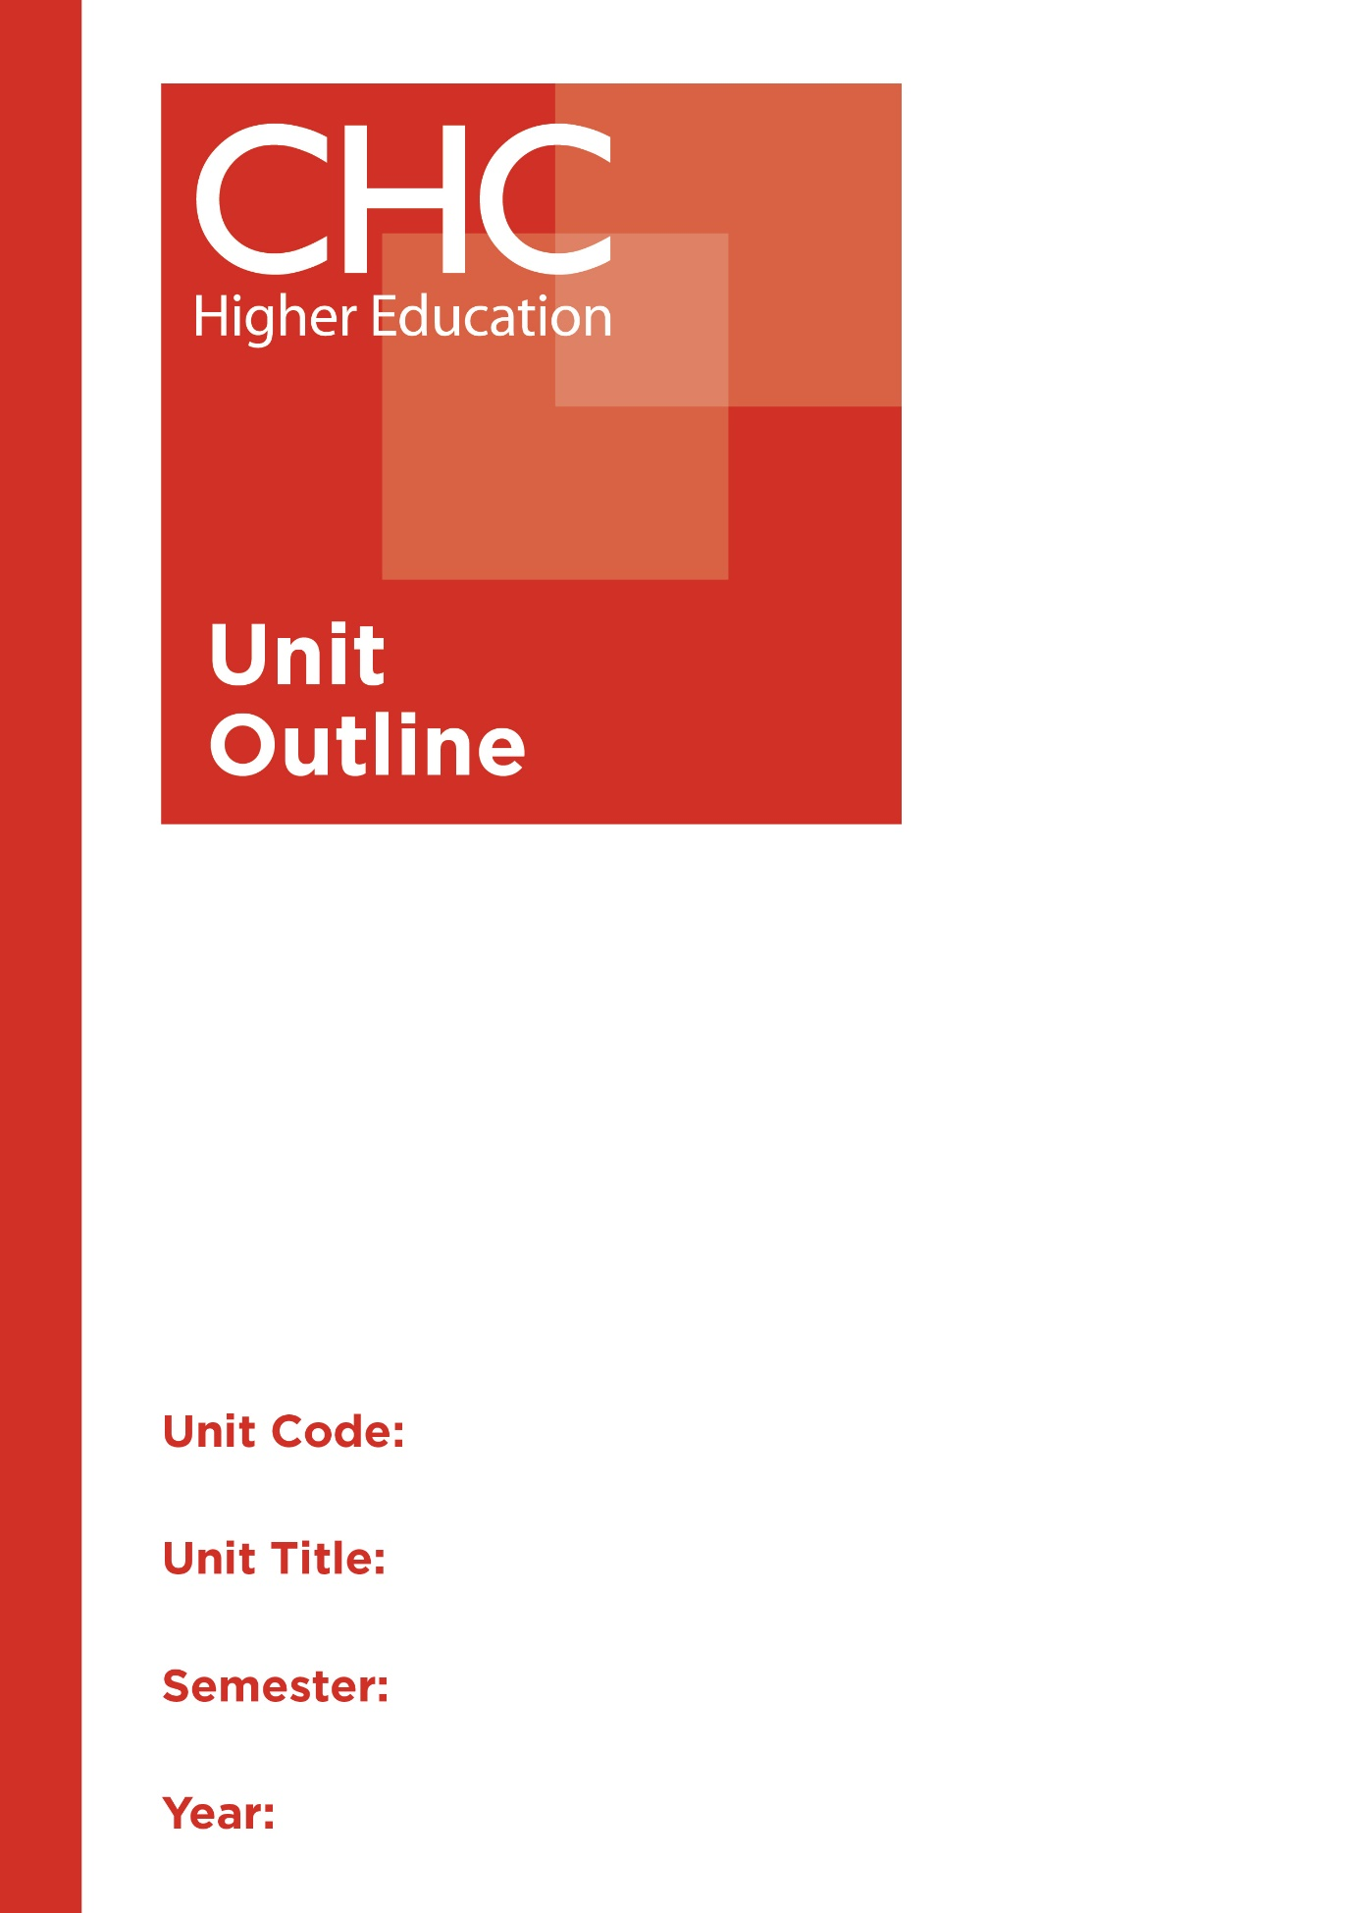

HP110
Health and Fitness
2

Unit code | HP110
Unit name | Health and Fitness
Associated higher education awards | Bachelor of Education (Secondary)  Bachelor of Arts/Bachelor of Education (Secondary)  Bachelor of Arts/Bachelor of Education (Secondary)
Duration | One Semester
Level | Introductory
Unit coordinator | Daniel Wolfik
Core/elective | Elective
Weighting | Unit credit points: 10  Course credit points: 320 - Bachelor of Education (Secondary)  320 - Bachelor of Arts/Bachelor of Education (Secondary)  320 - Bachelor of Arts/Bachelor of Education (Secondary)
Delivery mode | Face-to-face
Student workload | Contact hours/Directed Study 30 hours  Reading, study, preparation 50 hours  Assignment preparation 70 hours  TOTAL 150 hours
 | Students requiring additional English language support are expected to undertake an additional one hour per week.
Prerequisites/ co-requisites/ restrictions | Nil.
Rationale | Enduring Understanding:  Concerns have been expressed in various forums about Australia childhood obesity rates, which evidently have been increasing. Many children are spending long hours in sedentary pursuits, which can lead to public and personal health issues in later life. Students need to be exposed to Health and Physical Education (HPE) options to have the opportunity to know and enjoy the fun of play and the benefits of healthy behaviours. Sports of all sorts have long been a popular part of Australian life, and most schools have an active sporting program, requiring involvement by many teachers. This unit will help prepare students to appreciate the benefits of health and fitness in order to be inspired to instil HPE imperatives in secondary schools.  Students will develop an understanding of the concepts of health and fitness from a Christian worldview. The unit will introduce students to basic requirements, curriculum content, teaching and learning strategies, and practical opportunities to develop their own health and fitness to influence their practices and encourage them to model these practices in teaching HPE.
Learning delivery process | Interactive engagement through on-campus or online learning modes with full access to CHC’s learning portal of resources:  On-Campus mode  - Weekly lecture.  - Weekly tutorial (where applicable).  Plus, CHC learning portal resources (see below).  On-line mode  - CHC learning portal (Moodle™) including:  - Synchronous and asynchronous virtual lectures  (multi-user collaborative learning interfaces, lecture capture, interactive Power Point presentation and resources)  - lecture capture recordings bank  - weekly readings;  - learning guides;  - assessment guides  - Collaborative forums: Student forums and News forum.  - Turnitin assessment and feedback tool.  All unit outlines are reviewed prior to the offering of the unit to take account of student and lecturer feedback.
Content | 1. Health: Wellness; Eating Disorders Fitness and Learning  2. Personal and Community Health  3. Physical Fitness and Performance  4. Fitness - Benefits and Challenges  5. Teaching strategies for health and fitness in HPE  6. Health and fitness for student diversity
Learning Outcomes | On completion of this unit, pre-service teachers will have provided evidence that they have:  1. identified the knowledge and understanding necessary in health and fitness;  2. outlined and analysed key issues in health and fitness;  3. reflected on health and fitness from a Christian worldview perspectives;  4. related knowledge and understanding of health and fitness to curriculum practice;  5. critiqued and applied insights gained from reviews of published research papers; and  6. communicated at an appropriate tertiary standard: with special attention to design elements, grammars, usage, logical relations, style, referencing and presentation.
Assessment tasks | Task 1: Seminar (Demonstration)  Deliver a presentation to the other students from this unit, outlining how you would teach a lesson based on a health or fitness issue that is relevant to the year level you wish to teach.  Word Length/Duration: 1000 words + 15 minutes presentation  Weighting: 40%  Assessed: 6-8  Task 2: Personal Journal and Rationale (Reflections/Expositions)  A weekly journal of your reflections and responses to the current health and fitness issues that have been explored and discussed each week in the HPE 110 unit for a period of 6-weeks. Ensure you also do further research of published research in these areas each week to extend your understanding and provide comments and reflections for action, on these readings each week.  Word Length/Duration: 2000 words  Weighting: 60%  Assessed: 10
Assessment alignment | Assessment Task Learning Outcome Content Graduate Teacher Standards  Task 1 1-6 3-6 2.1,2.2,3.1.3.2,3.3  Task 2 1-3, 5-6 1-4 2.1
Prescribed text(s) | Walters, P. & Byl, J. (2013). Christian paths to health and wellness, 2nd edition. Champaigne, IL: Human Kinetics.  Selected readings will be available via the Moodle™ site for this unit.
Recommended readings | Curriculum Readings  Bushman, B. (Ed.). (2017). ACSM's complete guide to fitness & health (2nd ed.). Champaign, IL: Human Kinetics.  Callcott, D., Miller, J., & Wilson-Gahan, S. (2015). Health and physical education: preparing educators for the future (2nd ed.). Melbourne, VIC: Cambridge University Press.  Campbell, L. & Musumeci, J. (2005). Active children: healthy now and later. Watson, ACT: Early Childhood Australia.  Coombes, J. (2014). ESSA's student manual for health, exercise & sport assessment. Chatswood, NSW: Elsevier Australia.  Fabre, L. (2006). Building balance, agility and strength for juniors in sport. Cloverdale, WA: Fabre.  Glanz, K., Rimer, B. K. & Viswanath, K. (Eds.). (2015). Health behavior and health education theory, research, and practice. San Francisco, CA: Jossey-Bass.  Healey, J. (Ed.).(2013). Physical activity and fitness. Thirroul, NSW: The Spinney Press.  Pate, R., Oria, M. & Pilsbury, L. (Eds.). (2012). Fitness measures and health outcomes in youth /Committee on fitness measures and health outcomes in youth. Washington, D.C.: National Academies Press.  Ruskin, R. (2008). Outcomes 1 preliminary course: personal development, Health & Physical Education (2nd ed.). Brisbane, QLD: Wile.  Sharkey, B. J. & Gaskill, S. E. (2013). Fitness and health (7th ed.). Champaign, IL: Human Kinetics.  Williams, M. H. (2013). Nutrition for health, fitness & sport (10th international ed.) .Sydney, NSW: McGraw-Hill Higher Education.  Journals and Periodicals  Asia-Pacific Journal of Health, Sport & Physical Education.  In addition to the resources above, students should have access to a Bible, preferably a modern translation such as The Holy Bible: The New International Version 2011 (NIV 2011) or The Holy Bible: New King James Version (NKJV).  These and other translations may be accessed free on-line at http://www.biblegateway.com. The Bible app from LifeChurch.tv is also available free for smart phones and tablet devices.
Specialist resource requirements | Nil.

