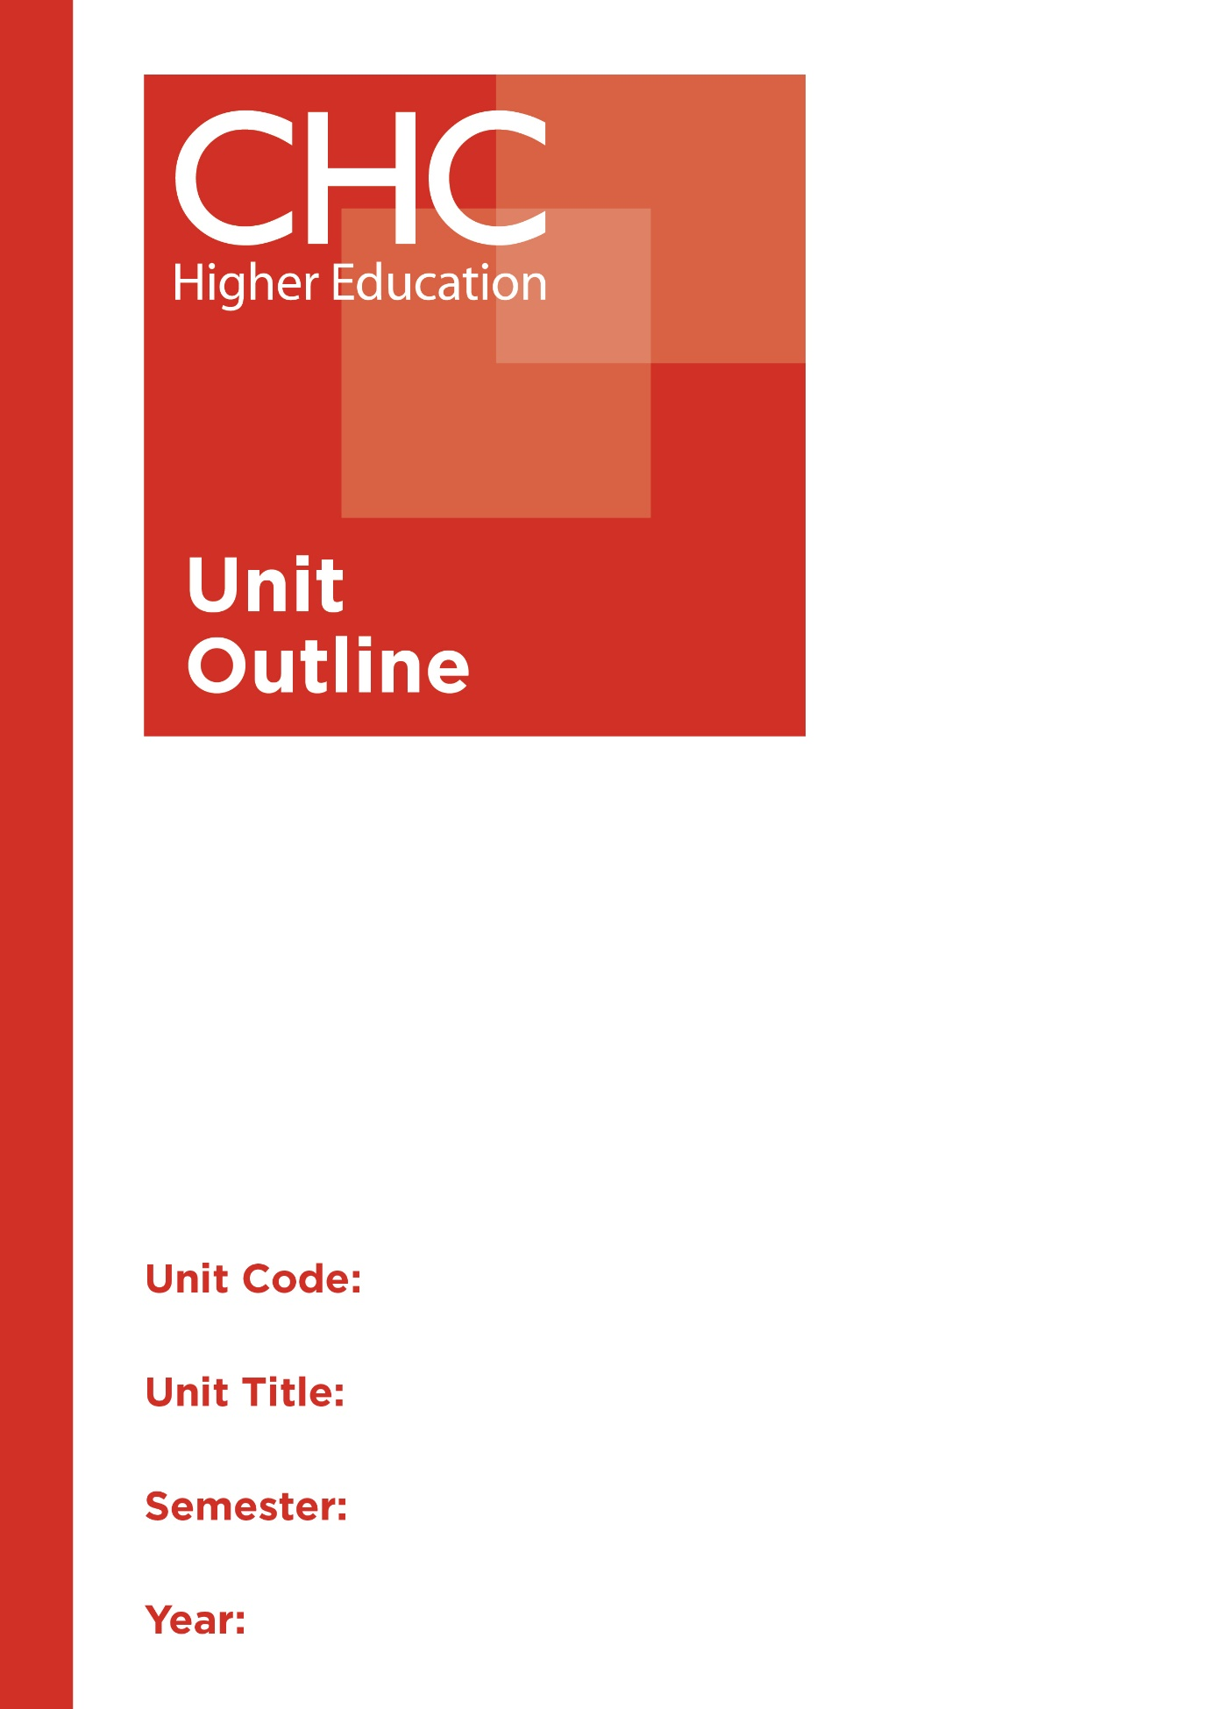

HP220
Games and Coaching
1

Unit code | HP220
Unit name | Games and Coaching
Associated higher education awards | Bachelor of Education (Primary)  Bachelor of Education (Secondary)  Bachelor of Arts/Bachelor of Education (Secondary)
Duration | One Semester
Level | Intermediate
Unit coordinator | Debra Ayling
Core/elective | Elective
Weighting | Unit credit points: 10  Course credit points: 320 - Bachelor of Education (Primary)  320 - Bachelor of Education (Secondary)  320 - Bachelor of Arts/Bachelor of Education (Secondary)
Delivery mode | Face-to-face
Student workload | Contact hours/Directed Study 30 hours  Reading, study, preparation 50 hours  Assignment preparation 70 hours  TOTAL 150 hours
 | Students requiring additional English language support are expected to undertake an additional one hour per week.
Prerequisites/ co-requisites/ restrictions | 20 credit points of introductory level HPE studies
Rationale | Enduring Understanding:  Coaching is a vital element of a quality sports program. Coaches have the potential to positively influence the development of young people as they motivate players, help them improve their skills, facilitate character development and gain confidence that can sustain them through the whole of life. Coaches need to be educated in the practices and principles of teaching skills and strategies of games, and understanding the elements of coaching.  This unit will address issues of human movement, skill development, games for understanding, strategies and the philosophical challenges of inspiring students in ‘games’ situations. Students will engage with both the theory and practices of coaching to encourage effective participation and engagement of people in a ‘games’ environment. They will explore how a Christian worldview perspective will impact the selection of strategies and contexts, for planning, organising, implementing, evaluating and reflecting on the coaching role. It introduces them to the historical background, principles, structures, models, delivery and evaluation necessary for coaching opportunities.
Learning delivery process | Interactive engagement through on-campus or online learning modes with full access to CHC’s learning portal of resources:  On-Campus mode  - Weekly lecture.  - Weekly tutorial (where applicable).  Plus, CHC learning portal resources (see below).  On-line mode  - CHC learning portal (Moodle™) including:  - Synchronous and asynchronous virtual lectures  (multi-user collaborative learning interfaces, lecture capture, interactive Power Point presentation and resources)  - lecture capture recordings bank  - weekly readings;  - learning guides;  - assessment guides  - Collaborative forums: Student forums and News forum.  - Turnitin assessment and feedback tool.  All unit outlines are reviewed prior to the offering of the unit to take account of student and lecturer feedback.
Content | 1. Introduction to Coaching.  2. Foundations of Teaching Games.  3. Foundations of Coaching.  4. Pedagogies and Practices in Games and Coaching  5. Whole-School Approaches to Games and Coaching
Learning Outcomes | On completion of this unit, pre-service teachers will have provided evidence that they have:  1. identified the key elements in teaching movement, skills development and positive attitudes in coaching games;  Graduate Attributes: 1,2,4  2. critically analysed advanced knowledge relevant to the coaching of games and sports;  Graduate Attributes: 1,2,4  3. reflected critically on Christian perspectives and approaches to coaching in games and sports;  Graduate Attributes: 2,3,7  4. developed coaching activities and strategies aligned with the theory and practice of coaching;  Graduate Attributes: 1,2,4  5. engaged with pedagogical strategies, tools and resources mediated through ICT technologies, relevant to coaching and games;  Graduate Attributes: 1,2,4  6. applied critical and methodological rigour to select appropriate skills and strategies for planning coaching experiences, including strategies and assessment for participants in games and coaching sessions; and  Graduate Attributes: 1,4  7. communicated at an appropriate tertiary standard: with special attention to design elements, grammars, usage, logical relations, style, referencing and presentation.  Graduate Attributes: 6
Assessment tasks | Task 1: Case Study Report  Through the observation of coaching sessions, you will critically analyse and report on the key elements involved in teaching movement, skill development and attitudes in coaching games.  Word Length/Duration: 1,500 words  Weighting: 40%  Assessed: Week 8  Task 2: Folio and Rationale  Part A: Develop a folio of three coaching sessions (following the lecturer’s template) for one of the groups of students observed in Assessment #1, for an alternate game/discipline.  Part B: Include a rationale (minimum of 500 words) in your Folio that includes a justification for your chosen coaching activities, strategies and assessment aligned with the theory and practice of coaching from this unit as well as your reflection upon a Christian perspective in relation to the human body and HPE imperatives  Word Length/Duration: 2,000 words  Weighting: 60%  Assessed: Week 16
Assessment alignment | Assessment Task Learning Outcome Content Graduate Teacher Standards  Task 1 1, 2, 4-7 1-5 2.1  Task 2 1,3-7 1-5 2.1
Prescribed text(s) | Sumich, K. (2013). Coaching children: Sports science essentials. Champaign, IL.: Acer Press.  Selected readings will be available via the Moodle™ site for this unit.
Recommended readings | Curriculum Readings  Boyd, A., Bultitude, S., & Wright, J. (2006). Exploring physical activity and sport. Gymea, NSW: Titan Education.  Cassidy, T., Jones, R., & Potrac, P. (2015). Understanding sports coaching: the social, cultural and pedagogical foundations of coaching practice (3rd ed.). New York, NY: Routledge.  Fabre, L. (2006). Building balance, agility and strength for juniors in sport. Cloverdale, WA: Fabre.  Jones, R. (Ed.). (2006). The sports coach as educator: re-conceptualising sports coaching. New York, NY: Routledge.  Jones, R., & Kingston, K. (Eds.). (2013). An introduction to sports coaching: connecting theory to practice. Abingdon, Oxon: Routledge.  Robinson, P. (2009). Foundations of sports coaching. Abingdon, Oxon: Routledge.  Rook, S., & Charles, T. (2013). 101 multi skill sports games. London, UK: Bloomsbury Sport.  Williams, J. (2015). Applied sport psychology: personal growth to peak performance. New York, NY: McGraw-Hill Higher Education.  Journals and Periodicals  Asia-Pacific Journal of Health, Sport & Physical Education  In addition to the resources above, students should have access to a Bible, preferably a modern translation such as The Holy Bible: The New International Version 2011 (NIV 2011) or The Holy Bible: New King James Version (NKJV).  These and other translations may be accessed free on-line at http://www.biblegateway.com. The Bible app from LifeChurch.tv is also available free for smart phones and tablet devices.
Specialist resource requirements | All students must participate in practical sessions using appropriate ‘sports’ attire including sports shoes and hat, bringing their own water and sunscreen.

