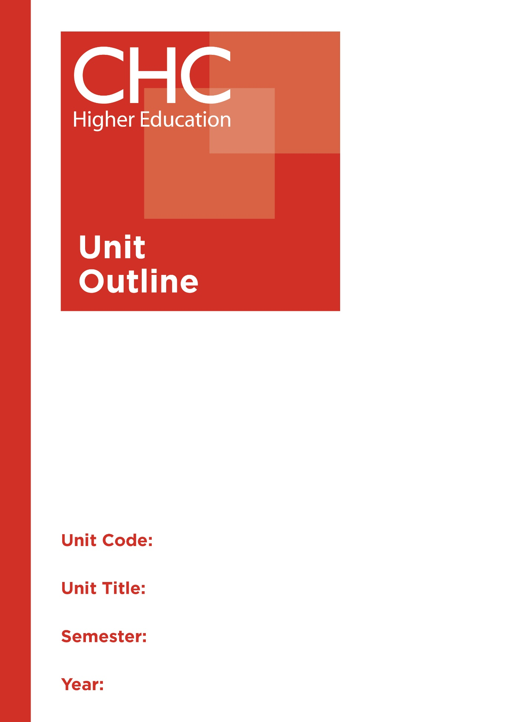

HP300
Psychology and Sociology of Sport
1

Unit code | HP300
Unit name | Psychology and Sociology of Sport
Associated higher education awards | Bachelor of Education (Secondary)  Bachelor of Arts/Bachelor of Education (Secondary)
Duration | One Semester
Level | Advanced
Unit coordinator | Debra Ayling
Core/elective | Elective
Weighting | Unit credit points: 10  Course credit points: 320 - Bachelor of Education (Primary)  320 - Bachelor of Education (Secondary)  320 - Bachelor of Arts/Bachelor of Education (Secondary)
Delivery mode | Internal
Student workload | Contact hours/Directed Study 30 hours  Reading, study, preparation 50 hours  Assignment preparation 70 hours  TOTAL 150 hours
 | Students requiring additional English language support are expected to undertake an additional one hour per week.
Prerequisites/ co-requisites/ restrictions | 20 credit points of 200-level HPE studies
Rationale | Enduring Understanding:  The intricate relationship between the mind, body and spirit influences the well-being and potential for active engagement of individuals and teams in sporting pursuits. Health and Physical Education teachers, coaches and trainers therefore need an understanding of sociological and psychological variables that influence people’s healthy engagement with sport and physical activity both in teams and as individuals.  Students will engage with psychological and sociological factors that influence human movement and participation in sport and consider how Christian worldview perspectives impact their views of and engagement with sport and movement. They will apply psychological and sociological theories of sport to assist in the development of teaching practices that encourage effective and holistic participation in sporting and movement activities.
Learning delivery process | Interactive engagement through on-campus or online learning modes with full access to CHC’s learning portal of resources:  On-Campus mode  - Weekly lecture.  - Weekly tutorial (where applicable).  Plus, CHC learning portal resources (see below).  On-line mode  - CHC learning portal (Moodle™) including:  - Synchronous and asynchronous virtual lectures  (multi-user collaborative learning interfaces, lecture capture, interactive Power Point presentation and resources)  - lecture capture recordings bank  - weekly readings;  - learning guides;  - assessment guides  - Collaborative forums: Student forums and News forum.  - Turnitin assessment and feedback tool.  All unit outlines are reviewed prior to the offering of the unit to take account of student and lecturer feedback.
Content | 1. Psychology and sociology in sport: an introduction to theory and practice.  2. Foundations and theories of psychology and sociology in sport and coaching.  3. Motivation and performance in sport and movement.  4. Teamwork, leadership and the social dimension of sport.  5. Gender issues and sports.  6. Indigenous sport in Australia.  7. Myths and paradoxes of sport and movement.  8. Competition, aggression and violence in sport.  9. Sport and the spiritual: considering a Christ-centred, Bible-based perspective.  10. Pedagogies and practices for sport and coaching.
Learning Outcomes | On completion of this unit, pre-service teachers will have provided evidence that they have:  1. understood and interrogated how foundational knowledge and theories of psychology and sociology influences engagement in sports and movement;  Graduate Attributes: 1,2,4,5  2. analysed and evaluated critically, issues that impact sports and movement using psychological and sociological theories and knowledge of sport;  Graduate Attributes: 1,2,4,5  3. analysed critically issues raised by commitment to Christian faith and engagement in sports and movement;  Graduate Attributes: 1,2,3,4  4. critically reflected upon issues raised by the psychology and sociology of sport and movement from a Christian perspective;  Graduate Attributes: 1,2,3,4,7  5. applied psychological and sociological theories to the development of pedagogies and practices for sport and movement; and  Graduate Attributes: 1,2,4,5  6. communicated at an appropriate tertiary standard, with special attention to design elements, grammar usage, logical relations, style, referencing and presentation.  Graduate Attributes: 6
Assessment tasks | Task 1: Investigation  Create a thesis statement to identify a core idea or concept related to the place of psychology and sociology in the teaching of sport and movement. This statement then needs to be explained and justified using quality research, providing explanations of these ideas in context.  Some suggested areas for context that may be considered but may not be limited to could be: Motivation and performance; Teamwork, leadership and the social dimension of sport; Gender issues in sport and/or; Indigenous sport in Australia. An example of this statement may be something like: “Internal motivation should be the key to training individual athletes to ultimately influence team success.”  Word Length/Duration: 2,000 words  Weighting: 40%  Assessed: Week 7  Task 2: Examination  The task will examine a number of scenarios to analyse, evaluate, critically reflect and develop recommended actions for coaches and teachers on the sociological and psychological factors that may influence their students’ engagement with sport and movement.  Word Length/Duration: 3 hours  Weighting: 60%  Assessed: Examination Week
Assessment alignment | Assessment Task Learning Outcome Content Graduate Teacher Standards  Task 1 1-4,6 1-10 2.1, 1.4,2.4  Task 2 1-6 1-10 2.1
Prescribed text(s) | Nil.  Selected readings will be available via the Moodle™ site for this unit.
Recommended readings | Curriculum Readings  Biddle, S. J. H., Mutrie, N. & Gorely, T. (2015). Psychology of physical activity: determinants, well-being and interventions. Oxon New York, NY Routledge.  Carron, A. V. & Eys, M. A. (2012). Group dynamics in sport. Morgantown, WV: Fitness Information Technology.  Coakley, J.L. (2016). Sports in society: issues and controversies. 12th Edition. New York, NY McGraw-Hill Education.  Cox, R. (2012). Sport psychology: concepts and applications. 7th Edition. New York : McGraw-Hill.  De la Pena, D. (2004). Scripture and sport psychology: mental-game techniques for the Christian athlete. Lincoln, NE: iUniverse.  Earnheardt, A. C., Haridakis, P. M. &. Hugenberg. B.S. (2012). Sports fans, identity, and socialization exploring the fandemonium. Lanham, MD: Lexington Books.  Eitzen, D. S. (2016). Fair and foul: beyond the myths and paradoxes of sport. Lanham, MD: Rowman & Littlefield Publishers.  Kerr, J. H. (2005). Rethinking aggression and violence in sport. London: Routledge.  Kremer, J. M. D., Moran, A., Craig, C. & Walker, G. (2011). Key concepts in sport psychology. London, UK: SAGE Publications.  Magdalinski, T. & Chandler, T. J. L. (Eds.). (2002). With God on their side: sport in the service of religion. London, UK: Routledge.  Walters, P. & Byl, J. (2013). Christian Paths to Health and Wellness 2nd ed.). Champaigne, IL: Human Kinetics United States.  Watson, N.J. & Parker. (2013). Sports and Christianity: historical and contemporary perspectives. New York, NY: Routledge.  Wib, L. (2012). Immortality in sports: a sociology of media, fame, and infamy. Boulder, CO: Paradigm Publishers.  Williams, J. M. (2014). Applied sport psychology : Personal growth to peak performance Applied sport psychology : Personal growth to peak performance. New York : McGraw-Hill.  In addition to the resources above, students should have access to a Bible, preferably a modern translation such as The Holy Bible: The New International Version 2011 (NIV 2011) or The Holy Bible: New King James Version (NKJV).  These and other translations may be accessed free on-line at http://www.biblegateway.com. The Bible app from LifeChurch.tv is also available free for smart phones and tablet devices.
Specialist resource requirements | All students must participate in practical sessions using appropriate ‘Sports’ attire including sports shoes and hat, bringing their own water and sunscreen.

