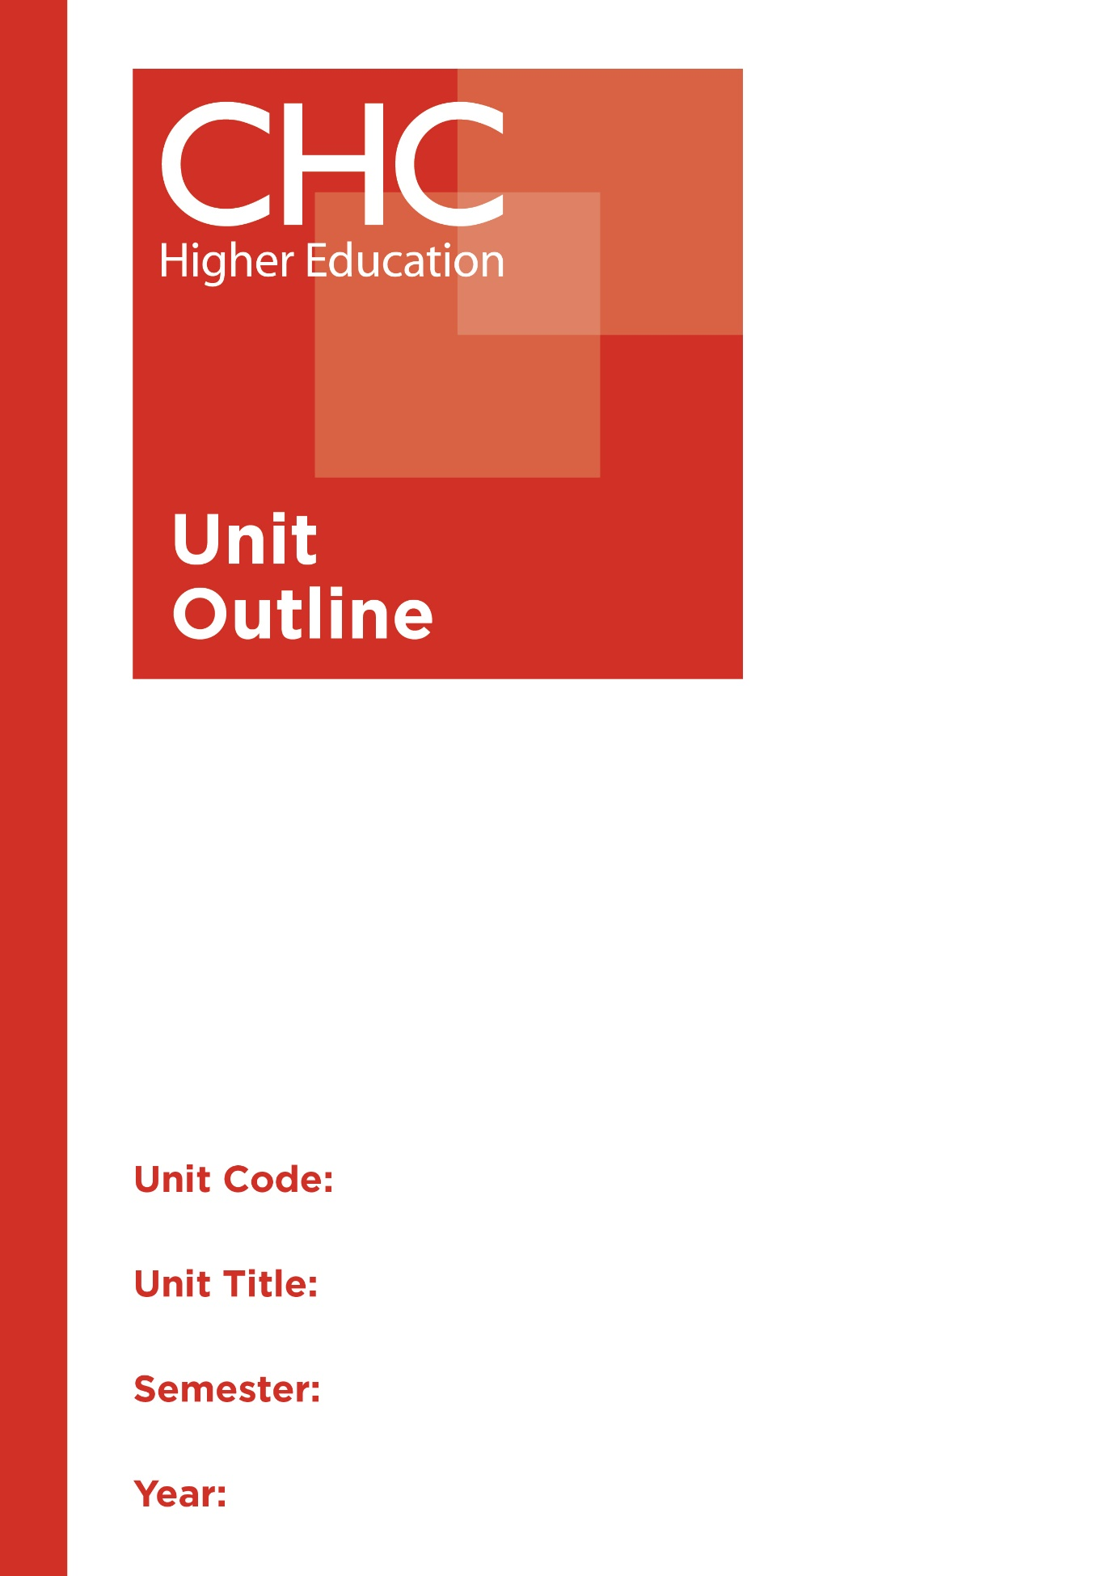

HP310
Sports Organisation and Management
1

Unit code | HP310
Unit name | Sports Organisation and Management
Associated higher education awards | Bachelor of Education (Primary)  Bachelor of Education (Secondary)  Bachelor of Arts/Bachelor of Education (Secondary)
Duration | One Semester
Level | Advanced
Unit coordinator | Debra Ayling
Core/elective | Core
Weighting | Unit credit points: 10  Course credit points: 320 - Bachelor of Education (Primary)  320 - Bachelor of Education (Secondary)  320 - Bachelor of Arts/Bachelor of Education (Secondary)
Delivery mode | On-campus/Online
Student workload | Contact hours/Directed Study 30 hours  Reading, study, preparation 50 hours  Assignment preparation 70 hours  TOTAL 150 hours
 | Students requiring additional English language support are expected to undertake an additional one hour per week.
Prerequisites/ co-requisites/ restrictions | 20 credit points of 200-level HPE studies
Rationale | Enduring Understanding:  Sport in an Australian context has had a deep and influential impact on Australian culture, at times drawing the community together and other times causing a clash between rival communities. With the globalisation of many sports, the local school or community club can now draw on the world-wide influences and opportunities available to enhance their performances, coaching and engagement with their sport. This unit develops an awareness of the key strategies and processes necessary to assess, analyse, direct and maintain an optimum environment for maximum quality participation of the school or community through organisation and management practices.  Students will explore the practices and principles of sports orgaisation and management. In doing so, it will address specifically, the historical place of sport in Australia, the philosophical challenges for sporting organisations, analysing school/club requirements, managing sporting events and suggesting appropriate planning, considerations and recommendations for the future. Students will explore the skills necessary in determining school requirements for sport and recreation activities as well as applying these skills to evaluate a sporting case study within the wider school community.
Learning delivery process | Interactive engagement through on-campus or online learning modes with full access to CHC’s learning portal of resources:  On-Campus mode  - Weekly lecture.  - Weekly tutorial (where applicable).  Plus, CHC learning portal resources (see below).  On-line mode  - CHC learning portal (Moodle™) including:  - Synchronous and asynchronous virtual lectures  (multi-user collaborative learning interfaces, lecture capture, interactive Power Point presentation and resources)  - lecture capture recordings bank  - weekly readings;  - learning guides;  - assessment guides  - Collaborative forums: Student forums and News forum.  - Turnitin assessment and feedback tool.  All unit outlines are reviewed prior to the offering of the unit to take account of student and lecturer feedback.
Content | 1. Historical place of sport in Australia; the development of sporting organisations  2. Philosophical challenges for sporting organisations  3. Practices and principles of sports management  4. Assessing the needs and goals of the sporting organisations/communities  5. Embracing community goals through prioritising and planning sports programs  6. Planning and management of sporting programs and organisations  7. Human resource mangagement in sports organisation and management  8. Risk management in sports organisation and management
Learning Outcomes | On completion of this unit, pre-service teachers will have provided evidence that they have:  - understood and interrogated principles and practices of sports organisation and management;  - identified, analysed and evaluated critically, issues that impact sports organisation and management;  1-5  - applied work health and safety considerations in sports oranisation and management contexts;  4  - critically reflected upon challenges and ethical issues arising from the management and organisation of sport using a Christian worldview perspective;  1-5  - applied critically principles and practices of sports organisation and management; and  4  - communicated at an appropriate tertiary standard: with special attention to design elements, grammars, usage, logical relations, style, referencing and presentation. 6  6
Assessment tasks | Task 1: Sporting Organisation Report  Students will be required to attend a Sporting Carnival/Event and then write a report identifying key elements from the carnival that relate specifically to sports organization and management. These elements may include the history and context of the event, the needs and goals of the organizational group and community related to this event, the philosophical and practical challenges, the planning, management and human resources required for the event and risk management practices. The report will provide an overview of the event, engaging with the above key elements, the outcome of the event and a future recommendations section that is based on discussion with the student and the event organizer.  Word Length/Duration: 2000 words  Weighting: 40%  Assessed: Week 8  Task 2: Management Action Plan  Consider the Major Sporting Event/Carnival that you reviewed in Task 1. Create a Management Action Plan for a future Sporting Event/Carnival that considers the positives and challenges that influenced this past event to assist in developing SMART goals in a future Management Action Plan. The Management Action Plan should demonstrate your understanding of the various key elements addressed in Task #1 and how you would address or enhance engagement with these elements in your future event.  Word Length/Duration: 2000 words  Weighting: 60%  Assessed: Week 14
Assessment alignment | Assessment Task Learning Outcome Content Graduate Teacher Standards  Task 1 1-3, 6 1-4,7 3.6, 4.4  Task 2 1-6 2-8 3.4, 4.1, 5.5, 6.3, 7.2
Prescribed text(s) | Lussier, R. N. & Kimball, D. C. (2014). Applied sport management skills. Leeds, UK: Human Kinetics.  Selected readings will be available via the Moodle™ site for this unit.
Recommended readings | Curriculum Readings  Byl, J. (2006). Organizing successful tournaments. (3rd edn.). Champaign, IL: Human Kinetics.  Dickson, T. J. & Gray, T. (2012). Risk management in the outdoors: a whole-of-organisation approach for education, sport and recreation. Port Melbourne, Vic., Cambridge University Press.  Hoye, R., Nicholson, M., Smith, A. Stewart, B. & Westerbeek, H. (2012). Sport management: principles and applications. (3rd edn.). Oxon, England: Routledge.  Hoye, R., Smith, A., Nicholson, M. & Stewart, B. (2018). Sport management: principles and applications. (5th ed.). Abingdon, London: Routledge.  Masteralexis, L. P., Barr, C. A. & Hums, M. A. (eds.). (2019). Principles and practice of sport management. (6th edn.). Burlington, MA: Jones and Bartlett Learning.  Robinson, L. & Palmer, D. (eds.). (2011). Managing voluntary sport organisations. London, UK: Routledge.  Shilbury, D., Phillips, P., Karg, A. & Rowe, K. (2017). Sport management in Australia: an  organisational overview. Crows Nest, NSW: Allen & Unwin.  Taylor, T., Doherty, A. & McGraw, P. (2015). Managing people in sport organizations: a strategic human resource management perspective. New York, NY: Routledge.  Journals and Periodicals  Asia-Pacific Journal of Health, Sport & Physical Education European sport management quarterly  In addition to the resources above, students should have access to a Bible, preferably a modern translation such as The Holy Bible: The New International Version 2011 (NIV 2011) or The Holy Bible: New King James Version (NKJV).  These and other translations may be accessed free on-line at http://www.biblegateway.com. The Bible app from LifeChurch.tv is also available free for smart phones and tablet devices.  In addition to the resources above, students should have access to a Bible, preferably a modern translation such as The Holy Bible: The New International Version 2011 (NIV 2011) or The Holy Bible: New King James Version (NKJV).  These and other translations may be accessed free on-line at http://www.biblegateway.com. The Bible app from LifeChurch.tv is also available free for smart phones and tablet devices.
Specialist resource requirements | Nil.

