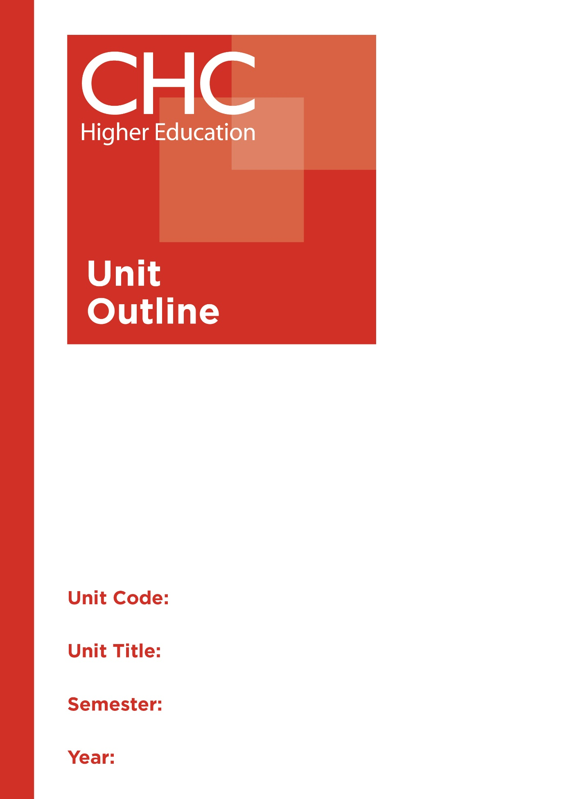

MT110
Foundations of Mathematics
1

Unit code | MT110
Unit name | Foundations of Mathematics
Associated higher education awards | Bachelor of Education (Primary)  Bachelor of Education (Secondary)  Bachelor of Arts/Bachelor of Education (Secondary)
Duration | One Semester
Level | Introductory
Unit coordinator | Karen du Plessis
Core/elective | Required for a minor in Mathematics
Weighting | Unit credit points: 10  Course credit points: 320 - Bachelor of Education (Primary)  320 - Bachelor of Education (Secondary)  320 - Bachelor of Arts/Bachelor of Education (Secondary)
Delivery mode | Face-to-face
Student workload | Contact hours/Directed Study 30 hours  Reading, study, preparation 50 hours  Assignment preparation 70 hours  TOTAL 150 hours
 | Students requiring additional English language support are expected to undertake an additional one hour per week.
Prerequisites/ co-requisites/ restrictions | Nil.
Rationale | Enduring Understanding:  This unit covers important basic concepts in algebra and trigonometry that a tertiary student is expected to master to undertake advanced mathematical concepts, such as calculus. Emphasis is placed on developing strong foundation mathematical skills in the areas including: polynomial, rational, exponential, logarithmic and trigonometric functions. The unit also covers topics of analytical geometry, matrices, sequences and statistics.  This course prepares future teachers by equipping them with a strong foundation of skills relating to a range of mathematical concepts that are needed in higher mathematics. Students will also investigate ways mathematics reveals the order of God’s creation.
Learning delivery process | Interactive engagement through on-campus or online learning modes with full access to CHC’s learning portal of resources:  On-Campus mode  - Weekly lecture.  - Weekly tutorial (where applicable).  Plus, CHC learning portal resources (see below).  On-line mode  - CHC learning portal (Moodle™) including:  - Synchronous and asynchronous virtual lectures  (multi-user collaborative learning interfaces, lecture capture, interactive Power Point presentation and resources)  - lecture capture recordings bank  - weekly readings;  - learning guides;  - assessment guides  - Collaborative forums: Student forums and News forum.  - Turnitin assessment and feedback tool.  All unit outlines are reviewed prior to the offering of the unit to take account of student and lecturer feedback.
Content | 1. Algebra.  2. Trigonometry.  3. Functions.  4. Complex numbers.  5. Analytic Geometry.  6. Matrices.  7. Introduction to statistics.  8. Sequences.
Learning Outcomes | On completion of this unit, pre-service teachers will have provided evidence that they have:  1. developed fluency in quantitative, algebraic and graphical manipulations;  2. executed simple mathematics with accuracy and clarity;  3. solved problems involving elementary but key mathematical ideas in algebra, geometry, trigonometry, and statistics;  4. developed and applied recognised processes to solve mathematical problems;  5. reflect on the order of God’s creation which mathematics reveals;  6. applied appropriate strategies to effectively communicate relevant mathematical concepts and arguments using either written English or mathematical notations, as appropriate; and  7. communicated at an appropriate tertiary standard: with special attention to design elements, grammars, usage, logical relations, style, referencing and presentation.
Assessment tasks | Task 1: Folio (Demonstration)  Word Length/Duration: 1 each week  Weighting: 20%  Assessed: Weekly  Task 2: Investigation and modelling (Investigation)  Word Length/Duration: 1500 words  Weighting: 30%  Assessed: Week 7  A percentage weighting is assigned to the Professional experience Folio to indicate its relative contribution to the assessment load for the unit. Successful completion of the Professional experience folio will constitute and ungraded pass and as such will not contribute to the calculation of the final unit grade.
Assessment alignment | Assessment Task Learning Outcome Content Graduate Teacher Standards  Task 1 1-4, 6  Task 2 1-7
Prescribed text(s) | Washington, A. (2013). Basic technical mathematics with calculus. (10th ed.). New York, NY: Pearson.  Selected readings will be available via the Moodle™ site for this unit.
Recommended readings | Curriculum Readings  Abramson, J. (2014). PreCalculus. Houston, TX: OpenStax College.  Croft, A., & Davison, R. (2010). Foundation Mathematics. (5th ed.). Essex, UK: Prentice-Hall.  Larson, R. (2014). Precalculus. (9th ed.). Boston, MA: Cengage Learning.  Safier, F. (2012). Schaum’s outline of precalculus. (3rd ed.). New York, NY: McGraw-Hill.  Stewart, J., Redlin, L., & Watson, S. (2015). Precalculus: Mathematics for calculus. (7th ed.). Boston, MA: Cengage Learning.  Sullivan, M. (2011). Precalculus. (10th ed.). New York, NY: Pearson.  In addition to the resources above, students should have access to a Bible, preferably a modern translation such as The Holy Bible: The New International Version 2011 (NIV 2011) or The Holy Bible: New King James Version (NKJV).  These and other translations may be accessed free on-line at http://www.biblegateway.com. The Bible app from LifeChurch.tv is also available free for smart phones and tablet devices.
Specialist resource requirements | Casio fx-82AU PLUS II scientific hand-calculator or equivalent

