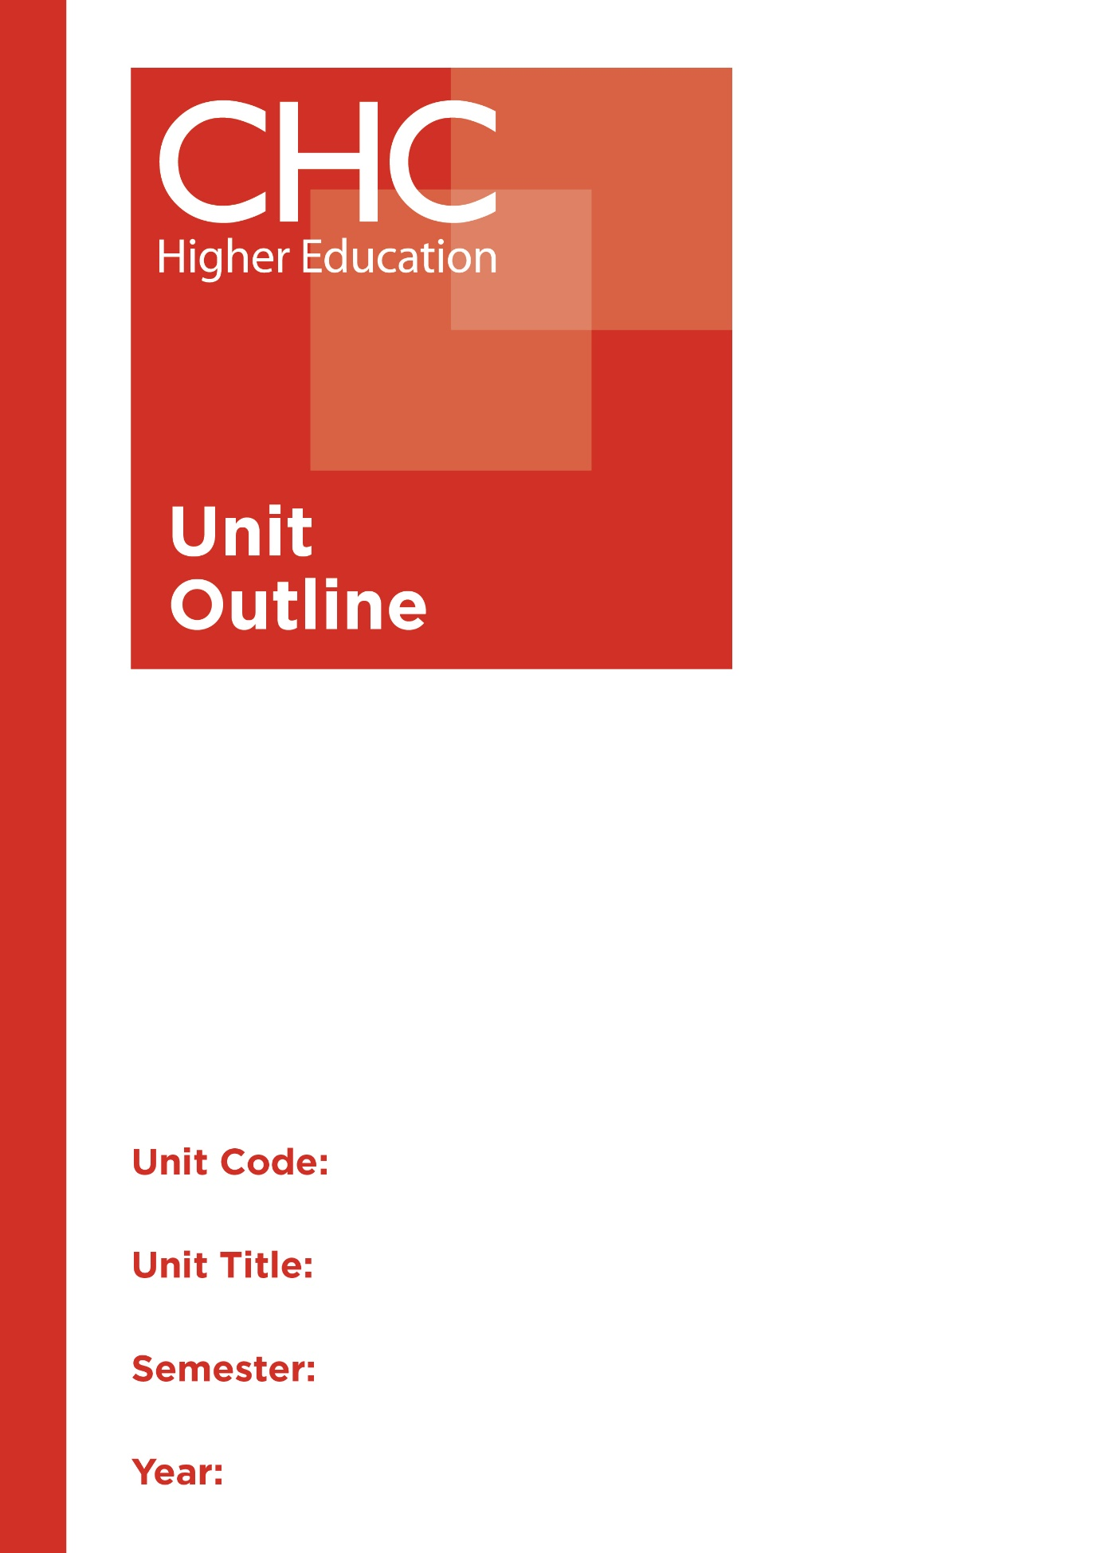

MT111
Calculus I
2

Unit code | MT111
Unit name | Calculus I
Associated higher education awards | Bachelor of Education (Primary)  Bachelor of Education (Secondary)  Bachelor of Arts/Bachelor of Education (Secondary)
Duration | One Semester
Level | Introductory
Unit coordinator
Core/elective | Core
Weighting | Unit credit points: 10  Course credit points: 320 - Bachelor of Education (Secondary)
Delivery mode | Face-to-face
Student workload | Contact hours/Directed Study 30 hours  Reading, study, preparation 50 hours  Assignment preparation 70 hours  TOTAL 150 hours
 | Students requiring additional English language support are expected to undertake an additional one hour per week.
Prerequisites/ co-requisites/ restrictions | Nil.
Rationale | Enduring Understanding:  According to the The Mathematics? Why Not? Report, prepared by the Australian Association of Mathematics Teachers and the University of New England, a key factor that deters students from studying higher level mathematics in senior secondary years is the large number of secondary teachers who are teaching mathematics outside their training and expertise. The authors state, “More than one-quarter of our junior secondary mathematics teachers have not even completed one year of university study in mathematics, making it difficult to engage students in a potentially demanding subject.”  This unit acts as a bridge between the students’ previous experience in mathematics and further tertiary study in mathematics. Students will engage with new mathematical concepts and will be presented both with theory and practical examples. Topics include trigonometric functions, basic vector algebra in two and three dimensions, log exponential, trigonometric and periodic functions, basic differential and integral calculus of one variable and partial derivatives. Most importantly, they will learn how to apply fundamental mathematical tools and techniques used in most fields of science, engineering and mathematics.  It is these applications that are essential for secondary classroom teachers to understand. Further, for the Christian teacher, developing a broader appreciation of the logic, order and consistency of such mathematical applications and how these reflect the character of God and His creation is of great significance. By weaving the cognitive with the eternal in this regard, it is possible for secondary classroom teachers to convey the relevance of higher level mathematics to their students and inspire them to higher levels of learning.
Learning delivery process | Interactive engagement through on-campus or online learning modes with full access to CHC’s learning portal of resources:  On-Campus mode  - Weekly lecture.  - Weekly tutorial (where applicable).  Plus, CHC learning portal resources (see below).  On-line mode  - CHC learning portal (Moodle™) including:  - Synchronous and asynchronous virtual lectures  (multi-user collaborative learning interfaces, lecture capture, interactive Power Point presentation and resources)  - lecture capture recordings bank  - weekly readings;  - learning guides;  - assessment guides  - Collaborative forums: Student forums and News forum.  - Turnitin assessment and feedback tool.  All unit outlines are reviewed prior to the offering of the unit to take account of student and lecturer feedback.
Content | 1. Vectors  2. Functions and limits  3. Differentiation  4. Integration  5. Sequences and series
Learning Outcomes | On completion of this unit, pre-service teachers will have provided evidence that they have:  1. developed fluency in using differential and integral calculus, vectors, functions, and sequences and series;  2. analysed mathematical problems to identify and apply relevant processes to solve such problems;  3. appreciated the logic, order and consistency of mathematics in relation to its reflection of both the character of God and His creation;  4. applied appropriate strategies to effectively communicate relevant mathematical concepts and arguments using either written English or mathematical notations, as appropriate; and  5. communicated at an appropriate tertiary standard: with special attention to design elements, grammars, usage, logical relations, style, referencing and presentation.
Assessment tasks | Task 1: Folio (Demonstration)  Word Length/Duration: 1 week  Weighting: 20%  Assessed: Weekly  Task 2: Investigation and Application (Investigation)  Word Length/Duration: 1500 words  Weighting: 30%  Assessed: 7  A percentage weighting is assigned to the Professional experience Folio to indicate its relative contribution to the assessment load for the unit. Successful completion of the Professional experience folio will constitute and ungraded pass and as such will not contribute to the calculation of the final unit grade.
Assessment alignment | Assessment Task Learning Outcome Content Graduate Teacher Standards  Task 1 1, 2, 4  Task 2 1-5
Prescribed text(s) | Stewart, J. (2015). Calculus: Early transcendentals (8th ed.). Boston, MA: Cengage Learning.  Selected readings will be available via the Moodle™ site for this unit.
Recommended readings | Adams, R.A., & Essex, C. (2013). Calculus: A complete course (8th ed.). New York, NY: Pearson.  Anton, H., Bivens, I., & Davis, S. (2012). Calculus: Early transcendentals. (10th ed.) New York, NY: Wiley.  Edwards, C.H., & Penney, D.E. (2002). Calculus, early transcendentals (matrix version) (6th ed.). Essex, UK: Prentice Hall.  Fitzgerald, G.F., & Peckham, E.A. (2005). Mathematical methods for engineers and scientists (4th ed.). Essex, UK: Prentice-Hall.  Larson, R., & Edwards, B. H. (2014). Calculus (10th ed.). Boston, MA: Cengage Learning.  Washington, A. (2013). Basic technical mathematics with calculus (10th ed.). New York, NY: Pearson.  In addition to the resources above, students should have access to a Bible, preferably a modern translation such as The Holy Bible: The New International Version 2011 (NIV 2011) or The Holy Bible: New King James Version (NKJV).  These and other translations may be accessed free on-line at http://www.biblegateway.com. The Bible app from LifeChurch.tv is also available free for smart phones and tablet devices.
Specialist resource requirements | Nil.

