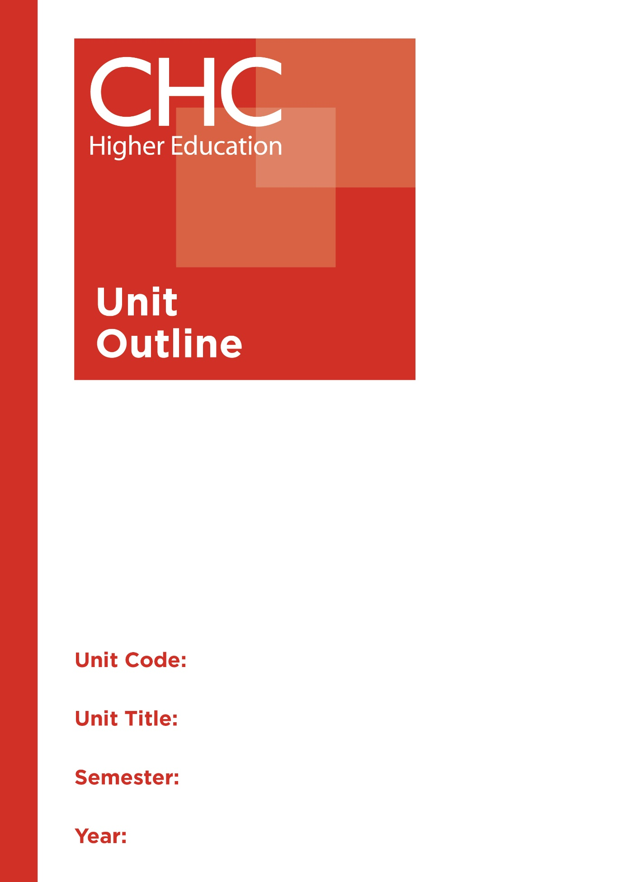

SC110
A Christian Approach to Scientific Inquiry

Unit code | SC110
Unit name | A Christian Approach to Scientific Inquiry
Associated higher education awards | Bachelor of Education (Primary)  Bachelor of Education (Secondary)  Bachelor of Arts/Bachelor of Education (Secondary)
Duration | One Semester
Level | Introductory
Unit coordinator | Fynn Stark
Core/elective | Elective
Weighting | Unit credit points: 10  Course credit points: 320 - Bachelor of Education (Primary)  320 - Bachelor of Education (Secondary)  320 - Bachelor of Arts/Bachelor of Education (Secondary)
Delivery mode | Internal
Student workload | Contact hours/Directed Study 30 hours  Reading, study, preparation 50 hours  Assignment preparation 70 hours  TOTAL 150 hours
 | Students requiring additional English language support are expected to undertake an additional one hour per week.
Prerequisites/ co-requisites/ restrictions | Nil.
Rationale | Enduring Understanding:  This unit introduces pre-service teachers to various ways scientists inquire into the natural world, by exploring issues that are emergent in the 21st century. It builds upon the key concepts developed in earlier introductory units with the aim to develop the concept of scientific investigation in conjunction with a Christian worldview.  At the core of science is the call to investigate and understand the world around us through an inquiry method. Students will discover the historic foundations of the scientific method developed through the Christian church. Issues such as geological timescale, origins and age of the universe, cloning, genetically modified organisms (GMO’s), animal welfare, IVF and cloning will be discussed. Students will be challenged to raise questions and reflect on the ethics of these questions through a faith based framework.
Learning delivery process | Interactive engagement through on-campus or online learning modes with full access to CHC’s learning portal of resources:  On-Campus mode  - Weekly lecture.  - Weekly tutorial (where applicable).  Plus, CHC learning portal resources (see below).  On-line mode  - CHC learning portal (Moodle™) including:  - Synchronous and asynchronous virtual lectures  (multi-user collaborative learning interfaces, lecture capture, interactive Power Point presentation and resources)  - lecture capture recordings bank  - weekly readings;  - learning guides;  - assessment guides  - Collaborative forums: Student forums and News forum.  - Turnitin assessment and feedback tool.  All unit outlines are reviewed prior to the offering of the unit to take account of student and lecturer feedback.
Content | 1. Christian historic foundations of the scientific method.  2. Scientific investigations.  3. Raising questions.  4. Ethics within a faith framework.  5. Animal welfare.  6. Cloning.  7. GMOs and genetic engineering.  8. IVF.  9. Creation vs Evolution.  10. Geological timescale.  11. The age of the universe.
Learning Outcomes | On completion of this unit, pre-service teachers will have provided evidence that they have:  1. developed knowledge and understanding of the major concepts related to biological, physical and chemical fields of scientific understanding and investigation;  2. developed skills of and appreciation for scientific investigation as a strategy for studying God’s creation;  3. reflected on biblical Christian worldview perspectives in relation to 21st century scientific dilemmas;  4. applied knowledge and skills to demonstrate autonomy, well-developed judgement, adaptability and responsibility about God’s creation;  5. developed and applied scientific knowledge and skills to analyse solutions to complex problems; an  6. communicated at an appropriate tertiary standard: with special attention to design elements, grammar, usage, logical relations, style and presentation.
Assessment tasks | Task 1: Investigative Report  Word Length/Duration: 2,500 words  Weighting: 30%  Assessed: Week 6  Task 2: Weekly reflections (Select the best 3)  Word Length/Duration: 200-300 words per week  Weighting: 30%  Assessed: Week 9  A percentage weighting is assigned to the Professional experience Folio to indicate its relative contribution to the assessment load for the unit. Successful completion of the Professional experience folio will constitute and ungraded pass and as such will not contribute to the calculation of the final unit grade.
Assessment alignment | Assessment Task Learning Outcome Content Graduate Teacher Standards  Task 1 1-6  Task 2 2-4,6
Prescribed text(s) | Ashton, J. (2001). The God Factor: 50 Scientists and academics explain why they believe in God. Pymble, NSW: HarperCollins.  Selected readings will be available via the Moodle™ site for this unit.
Recommended readings | Curriculum Readings  Alexander, D. (2014). Creation or evolution: Do we have to choose? Sydney, NSW: Monarch Books.  Alexander, D. (Ed.). (2007). Can we be sure about anything?: Science, faith and postmodernism. Cambridge, UK: International Society for Science and Religion.  Carlson, R. F., & Longman III, T. (2010). Science, creation and the bible: reconciling rival theories of origins. Downers Grove IL: InterVarsity Press.  Collins, F. (2006). The language of God: A scientist presents evidence for belief. (111th ed.). New York, NY: Simon and Schuster.  Giberson, K., & Collins, F. (2011). The language of science and faith: Straight answers to genuine questions. Downers Grove IL: InterVarsity Press.  Jeeves, M. (Ed.). (2004). From cells to souls, and beyond: Changing portraits of human nature. Cambridge, UK: Wm. B. Eerdmans Publishing  Polkinghorne, J. (2003). The God of hope and the end of the world. Yale: Yale University Press.  Schaefer, H. (2013). Science and Christianity: conflict or coherence? (2nd ed). Apollos Trust.  Journals and Periodicals  Stanford, R. (1961). ‘Christian and the scientific method’. Westminster Theological Journal. 25:1, 1-28.  In addition to the resources above, students should have access to a Bible, preferably a modern translation such as The Holy Bible: The New International Version 2011 (NIV 2011) or The Holy Bible: New King James Version (NKJV).  These and other translations may be accessed free on-line at http://www.biblegateway.com. The Bible app from LifeChurch.tv is also available free for smart phones and tablet devices.
Specialist resource requirements | Nil.

