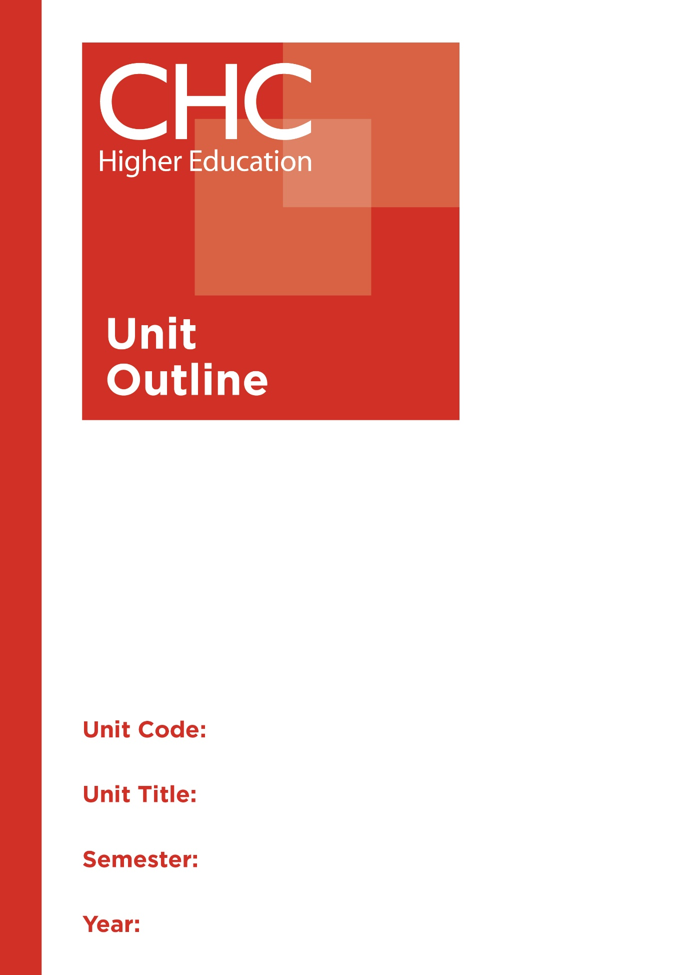

SC120
Environmental Science
2

Unit code | SC120
Unit name | Environmental Science
Associated higher education awards | Bachelor of Education (Primary)  Bachelor of Education (Secondary)  Bachelor of Arts/Bachelor of Education (Secondary)
Duration | One Semester
Level | Introductory
Unit coordinator | Fynn Stark
Core/elective | Elective
Weighting | Unit credit points: 10  Course credit points: 320 - Bachelor of Education (Primary)  320 - Bachelor of Education (Secondary)  320 - Bachelor of Arts/Bachelor of Education (Secondary)
Delivery mode | Internal
Student workload | Contact hours/Directed Study 30 hours  Reading, study, preparation 50 hours  Assignment preparation 70 hours  TOTAL 150 hours
 | Students requiring additional English language support are expected to undertake an additional one hour per week.
Prerequisites/ co-requisites/ restrictions | Nil.
Rationale | Enduring Understanding:  Over several decades there has been growing interest in and concern for the world’s environmental systems and climate, and the sustainability of human life and society in light of pressures placed on the environment by human activity. Environmental science explores the Earth, with a view to developing a balanced approach to pressures of developing, extracting, adapting and utilising the natural resources and ecosystems of God’s creation. Global climate change is a topical issue which will require forward-thinking and strategic efforts by contemporary society in areas of mitigation and adaptation for the benefit and welfare of future generations. Students will engage with environmental issues in ways that are scientifically informed, based on values of stewardship, conservation, equity and biodiversity. In particular, students will examine principles of sustainability, as a guiding principle for evaluating human activity and its impact on local and global environments.  This unit exposes preservice teachers to key concepts involved in environmental protection and management, and uses a variety of strategies to raise awareness of associated issues including field studies, focused research, group investigations and discussions.
Learning delivery process | Interactive engagement through on-campus or online learning modes with full access to CHC’s learning portal of resources:  On-Campus mode  - Weekly lecture.  - Weekly tutorial (where applicable).  Plus, CHC learning portal resources (see below).  On-line mode  - CHC learning portal (Moodle™) including:  - Synchronous and asynchronous virtual lectures  (multi-user collaborative learning interfaces, lecture capture, interactive Power Point presentation and resources)  - lecture capture recordings bank  - weekly readings;  - learning guides;  - assessment guides  - Collaborative forums: Student forums and News forum.  - Turnitin assessment and feedback tool.  All unit outlines are reviewed prior to the offering of the unit to take account of student and lecturer feedback.
Content | 1. Anthropogenic environmental and climate change: the physical sciences basis  2. Science and the environment: human impact, protection, stewardship and management  3. Sustainability in environmental science: knowledge and attitudes relevant to changing behaviour for enhanced “creation care” and improved environmental outcomes  4. Principles, models and practices for environmental science, including sustainability  5. Researching environmental issues: current best practices, issues and perspectives; sustainability  6. Christian attitudes to the environment; exploring Christian perspectives on environmental protection based on Biblical foundations
Learning Outcomes | On completion of this unit, pre-service teachers will have provided evidence that they have:  1. developed knowledge and understanding of the concepts of Environmental Science, including sustainability;  2. analysed the role of human impact upon the environment using scientific enquiry;  3. demonstrated an appreciation of the importance of ethical and moral practices in environmental science, from a biblical worldview perspective;  4. considered and proposed environmental science protection and management strategies using perspectives based on biblical foundations;  5. reflected on scientific models, principles and practices of environmental science;  6. developed and applied advanced scientific knowledge and skills for researching environmental issues; and  7. communicated at an appropriate tertiary standard: with special attention to design elements, grammar, usage, logical relations, style and presentation.
Assessment tasks | Task 1: (A) Scientific Report and (B) Inquiry into a Sustainability Issue  Word Length/Duration: 1500 words  Weighting: 40%  Assessed: Week 6  Task 2: Bulimba Creek field study  In the role of an environmental scientist complete an in-depth study of the Bulimba Creek catchment on which CHC is situated. Develop an Environmental Report Card with recommendations for improving the quality of the catchment environment and implementation of at least one of practical recommendations.  The Environmental Report Card will consider:  • Christian worldview response and reflection  • Components of an ecosystem  • Interactions between organisms  • Biomass, energy and matter flow through the ecosystems  • Impacts of human activity  • Ecosystem protection and management  • Implementation of practical strategy  Word Length/Duration: 2500 words  Weighting: 60%  Assessed: Week 9  A percentage weighting is assigned to the Professional experience Folio to indicate its relative contribution to the assessment load for the unit. Successful completion of the Professional experience folio will constitute and ungraded pass and as such will not contribute to the calculation of the final unit grade.
Assessment alignment | Assessment Task Learning Outcome Content Graduate Teacher Standards  Task 1 1-7  Task 2 3,4,5,7
Prescribed text(s) | Nil.  Selected readings will be available via the Moodle™ site for this unit.
Recommended readings | Curriculum Readings  Brunner, D. L., Butler, J. L. & Swoboda, A. J. (2014). Introducing evangelical ecotheology: Foundations in scripture, theology, history and praxis. MI, USA: Baker Academic.  Cook, J. & Bedford, D. (2016). Climate change: Examining the facts. California, USA: ABC-CLIO, LLC.  Cunningham, W. & Cunningham, M. (2015). Environmental science: A global concern (13th ed.). New York, USA: McGraw-Hill Education.  Gilbert, R. & Hoepper, B. (2011). Teaching Society and Environment (4th ed.). Victoria, Australia: Cengage Learning Australia Pty Ltd.  Gilbert, R. & Hoepper, B. (Eds.) (2014). Teaching Humanities and Social Sciences: History, Geography, Economics and Citizenship in the Australian Curriculum, (5th ed.). Cengage Learning, South Melbourne  Miller, T. G. & Spoolman, S. E., (2015). Living in the environment (18th ed.). Belmont, California: Brooks/Cole.  Reynolds, R. (2012). Teaching history, geography and SOSE in the primary school. Australia: Oxford University Press.  Journals and Periodicals  The Australian Science Teachers' Journal  Journal of Technology Education  Perspectives on Science and Christian Faith  Christian  Websites  Australian Academy of Science:  https://www.science.org.au/  Commonwealth Scientific and Industrial Research Organisation:  https://www.csiro.au/  Scootle Science:  https://www.scootle.edu.au/ec/search?q=science&field=title&field=text.all&field=topic  Australian Science Teachers Association:  http://asta.edu.au/  Australasian Science Magazine:  www.australasianscience.com.au/  ABC Science Online:  www.abc.net.au/science  ABC Science Online:  www.abc.net.au/science  In addition to the resources above, students should have access to a Bible, preferably a modern translation such as The Holy Bible: The New International Version 2011 (NIV 2011) or The Holy Bible: New King James Version (NKJV).  These and other translations may be accessed free on-line at http://www.biblegateway.com. The Bible app from LifeChurch.tv is also available free for smart phones and tablet devices.
Specialist resource requirements | Nil.

