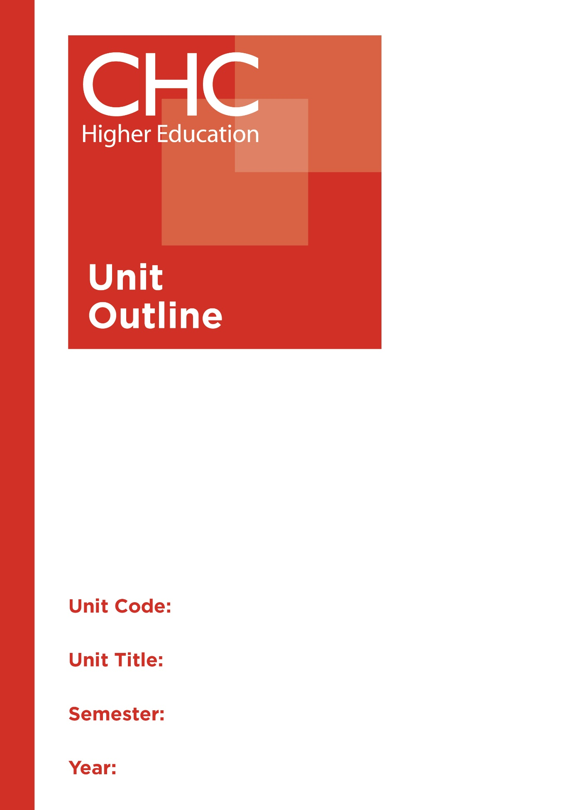

SC130
Physical and Chemical Sciences (7-10)
1

Unit code | SC130
Unit name | Physical and Chemical Sciences (7-10)
Associated higher education awards | Bachelor of Education (Secondary)
Duration | One Semester
Level | Intermediate
Unit coordinator | Peter Collins
Core/elective | Elective
Weighting | Unit credit points: 10  Course credit points: 320 - Bachelor of Education (Secondary)
Delivery mode | Internal
Student workload | Contact hours/Directed Study 30 hours  Reading, study, preparation 50 hours  Assignment preparation 70 hours  TOTAL 150 hours
 | Students requiring additional English language support are expected to undertake an additional one hour per week.
Prerequisites/ co-requisites/ restrictions | Nil.
Rationale | Enduring Understanding:  Effective science teachers are scientifically knowledgeable and literate and confident in a range of pedagogies that motivate learners and promote scientific inquiry into God’s creation.  Developing engaging practices in the classroom will encourage secondary (years 7-10) students to participate in scientific inquiry processes. Pre-service teachers will be equipped to encourage students to develop an ongoing interest in science.  This unit will prepare pre-service teachers to engage learners with the scientific strands of chemistry and physics within the Australian Curriculum in conjunction with developing pedagogical practice and revelation of Christian worldview perspectives.
Learning delivery process | Interactive engagement through on-campus or online learning modes with full access to CHC’s learning portal of resources:  On-Campus mode  - Weekly lecture.  - Weekly tutorial (where applicable).  Plus, CHC learning portal resources (see below).  On-line mode  - CHC learning portal (Moodle™) including:  - Synchronous and asynchronous virtual lectures  (multi-user collaborative learning interfaces, lecture capture, interactive Power Point presentation and resources)  - lecture capture recordings bank  - weekly readings;  - learning guides;  - assessment guides  - Collaborative forums: Student forums and News forum.  - Turnitin assessment and feedback tool.  All unit outlines are reviewed prior to the offering of the unit to take account of student and lecturer feedback.
Content | 1. Australian Curriculum Science Understandings 7-10 (Physical and Chemical Sciences):  a) Year 7 – Mixtures, solutions and separation processes, forces and gravity;  b) Year 8 - States of matter, elements, compounds and mixtures, chemical change, energy forms and transformation;  c) Year 9 - Atomic structure, chemical reactions (acid/base, combustion), energy transfer: heat, electricity, sound and light;  d) Year 10 – Atomic structure and periodic table patterns, chemical reaction rate and balancing equations, energy conservation and systems, simple motion.  2. Science inquiry skills: Questioning, predicting; planning and conducting; data collecting, analysis and processing; evaluating; communicating.  3. Science as a human endeavour real-world application, influence upon society.  4. Teaching strategies especially upon laboratory practice.  5. Laboratory safety and risk management.  6. Christian worldview integration and revelation of God’s created order.
Learning Outcomes | On completion of this unit, pre-service teachers will have provided evidence that they have:  1. developed Australian Curriculum chemical and physical Science content knowledge and understanding for years 7-10;  Graduate Teacher Standards: 2.1  Graduate Attributes: 4,7  2. acquired and applied scientific inquiry skills for physical and chemical science;  Graduate Teacher Standards: 2.1  Graduate Attributes: 4,7  3. developed innovative teaching strategies for teaching physical and chemical sciences in the years 7-10 context;  Graduate Teacher Standards: 2.1  Graduate Attributes: 1,4  4. examined chemical and physical science applications as a human endeavour;  Graduate Teacher Standards: 2.5,2.6,4.5  Graduate Attributes: 1,4  5. investigated the ways physical and chemical sciences reveal God’s order in creation; and  Graduate Attributes: 3  6. communicated at an appropriate tertiary standard, with special attention to design elements, grammar usage, logical relations, style, referencing and presentation.  Graduate Attributes: 6
Assessment tasks | Task 1: Experimental Reports  Undertake three practical scientific investigations and write individual experimental reports. Investigative areas include Chemical reactions; Chemical Energy transformations; Simple motion studies and energy topic practical demonstration.  Word Length/Duration: 3x1,000 words  Weighting: 60% total (3x20%)  Assessed: Throughout semester weeks 1-9  Task 2: Examination  Examination of content, knowledge and understandings, and scientific skills drawn from Australian Curriculum Chemical and physical science 7-10 learning areas.  Word Length/Duration: 3 hours  Weighting: 40%  Assessed: Examination week  A percentage weighting is assigned to the Professional experience Folio to indicate its relative contribution to the assessment load for the unit. Successful completion of the Professional experience folio will constitute and ungraded pass and as such will not contribute to the calculation of the final unit grade.
Assessment alignment | Assessment Task Learning Outcome Content Graduate Teacher Standards  Task 1 1-6 1-6 2.1,3.3,3.4  Task 2 1-6 1-6 2.1
Prescribed text(s) | Nil.  Selected readings will be available via the Moodle™ site for this unit.
Recommended readings | Curriculum Readings  Blackman, A., Bottle, S., Schmid, S., Mocerino, M., & Wille, U. (2016). Chemistry. (3rd ed.). Milton, QLD: John Wiley and Sons.  Bonomo, R., Tabbi, G., & Guiffrida, A. (2013). A conceptual approach to the teaching of chemistry. New York, NY: Novinka.  Bowman, M. & Haysom, J. (2014). Predict, observe, explain: Activites enhancing science understanding. Moorabbin, VIC: Hawker Brownlow Education.  Halliday, D., Resnick, R., & Walker, J. (2014). Fundamentals of physics. (10th ed.). Milton, QLD: John Wiley and Sons.  Mader, J. & Winn, M. (2012). Teaching physics for the first time. (2nd ed.). College Park, MD: American Association of Physics Teachers.  Young, S. (2016). Gourmet Lab: The scientifc principles behind your favourite foods. Moorabbin, VIC: Hawker Brownlow Education.  Journals and Periodicals  The Australian Science Teachers' Journal  Journal of Technology Education  Perspectives on Science and Christian Faith  Christian  Websites  Australian Academy of Science:  https://www.science.org.au/  Commonwealth Scientific and Industrial Research Organisation:  https://www.csiro.au/  Scootle Science:  https://www.scootle.edu.au/ec/search?q=science&field=title&field=text.all&field=topic  Australian Science Teachers Association:  http://asta.edu.au/  Australasian Science Magazine:  www.australasianscience.com.au/  ABC Science Online:  www.abc.net.au/science  ABC Science Online:  www.abc.net.au/science  In addition to the resources above, students should have access to a Bible, preferably a modern translation such as The Holy Bible: The New International Version 2011 (NIV 2011) or The Holy Bible: New King James Version (NKJV).  These and other translations may be accessed free on-line at http://www.biblegateway.com. The Bible app from LifeChurch.tv is also available free for smart phones and tablet devices.
Specialist resource requirements | Nil.

