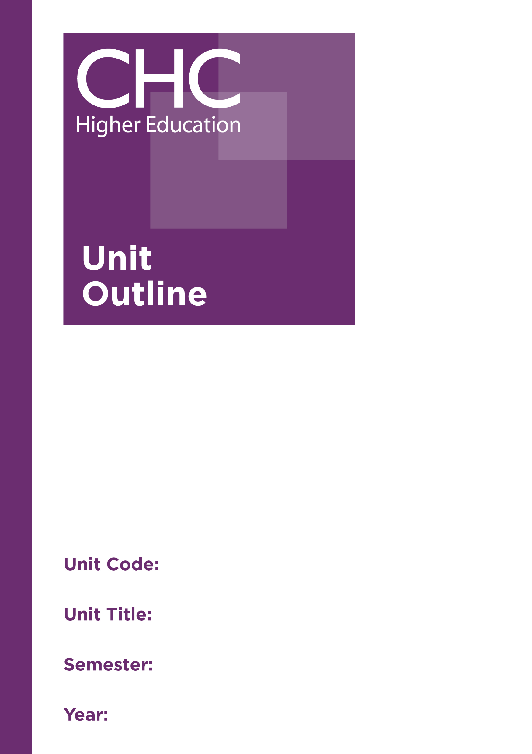
Unit Code: TR540

Unit Title: Trauma Counselling: Theoretical
Foundations

Semester: 1

Year: 2020

Unit code | TR540
Unit name | Trauma Counselling: Theoretical Foundations
Associated higher education awards | Graduate Certificate in Counselling Practice  Master of Counselling Practice  Master of Counselling
Duration | One semester
Level | Postgraduate
Unit coordinator | Toni Neil
Core/elective | Elective
Weighting | Unit credit points: 10  Course credit points: Graduate Certificate in Counselling Practice 80  Master of Counselling Practice 120  Master of Counselling 160
Delivery mode | Face-to-face on site  External
Student workload | Face-to-face on site  Contact hours 35 hours  Reading, study, and preparation 55 hours  Assignment preparation 60 hours  TOTAL 150 hours  External  Engagement with study materials 90 hours  Assignment preparation 60 hours  TOTAL 150 hours
 | Students requiring additional English language support are expected to undertake an additional one hour per week.
Prerequisites/ co-requisites/ restrictions | Nil
Rationale | Trauma is all around us and, with the 24-hour news cycle, we are perhaps more aware of it than ever before. Trauma is identified in survivors of war, returning soldiers, refugees, and those who have been tortured for their beliefs or lifestyle; however, there is also the often hidden trauma suffered by those who experience family violence, sexual assault, childhood abuse and neglect. Many of these clients seek counselling years later with other presenting issues; however, these are often symptoms of the underlying issue, the hidden unresolved trauma.  This unit focuses on preparing students with the knowledge, understanding and skills to work with clients who are experiencing difficulties from unresolved trauma in their past. It aims to establish a theoretical framework and develop a solid understanding of the neuroscience of traumatic response, based on the latest research.
 | This unit will also enable students to define trauma, types of trauma, and identify traumatic responses in themselves and others. Students will also have the opportunity to begin to synthesise their theoretical knowledge and Christian worldview perspectives into a practice framework.
Prescribed text(s) | Langberg, D. (2015). Suffering and the heart of God: How trauma destrys and Christ restores. Greensboro, NC: New Growth Press.  Van der Kolk, B. (2014). The body keeps the score: Brain, mind and body in the healing of trauma. New York, NY: Penguin.
Recommended readings | Books  Bremner, J. D. (2012). Does stress damage the brain: Understanding trauma-related disorders from a mind-body perspective. New York, NY: Norton.  Courtois, C. (2014). It’s not you, it’s what happened to you: Complex trauma and treatment [Kindle edition]. Dublin, OH: Telemachus Press.  Herman, J. (2015). Trauma and recovery: The aftermath of violence-from domestic violence to political terror. New York, NY: Basic Books.  Jones, S. (2009). Trauma and grace: Theology in a ruptured world. Louisville, KY: Westminster John Knox Press.  Levers, L. (Ed.). (2012). Trauma counselling: Theories and interventions. New York, NY: Springer.  Porges, S. (2011). Polyvagal theory: Neurophysiological foundations of emotions, attachment, communication, self-regulation. New York, NY: Norton.  Rambo, S., & Keller, C. (2010). Spirit and trauma: A theology of remaining. Louisville, KY: Westminster John Knox Press.  Sieff, D. (Ed.). (2015). Understanding and healing emotional trauma: Conversations with pioneering clinicians and researchers. New York, NY: Routledge.  Siegel, D. (2012). The developing mind: How relationships and the brain interact to shape who we are (2nd ed.). New York, NY: Guilford.  Wright, H. N. (2011). The complete guide to crisis and trauma counselling. Minneapolis, MN: Bethany House.  Journals and Periodicals  Developmental Neurobiology  Journal of Child Sexual Abuse  Journal of Interpersonal Violence  Journal of Neuroscience  Journal of Psychology and Theology  Sexual Abuse: A Journal of Research and Treatment  Traumatology  In addition to the resources above, students should have access to a Bible, preferably a modern translation such as The Holy Bible: The New International Version 2011 (NIV 2011) or The Holy Bible: New King James Version (NKJV).  These and other translations may be accessed free on-line at http://www.biblegateway.com. The Bible app from LifeChurch.tv is also available free for smart phones and tablet devices.
Specialist resource requirements | Nil
Content | - Defining trauma and traumatic events  - Trauma theory and types of trauma  - Trauma and the family system  - Neurobiology of the developing brain  - The neurobiology of trauma  - The impact of early trauma on the brain  - Neurobiology of attachment and traumatic attachment  - Neural integration as the goal of therapy  - Cultural and worldview perspectives of trauma  - Developing a bio-psycho-socio-spiritual framework for conceptualising trauma  - Post-Traumatic Stress Disorder  - Complex trauma
Learning outcomes | On completion of this unit, students will have demonstrated that they have:  - developed an advanced theoretical knowledge of different types of trauma and traumatic responses;  - critically analysed the neurological basis of traumatic response;  - developed the capacity to identify traumatic responses in themselves and others;  - critically analysed the prevalence and impact of childhood trauma-related disorders;  - critically reflected on Christian worldview perspectives of trauma and traumatic events;  - synthesised knowledge and understanding of trauma, trauma-related disorders, and neurobiology; and  - communicated at an appropriate tertiary standard with special attention to correct grammars, punctuation, spelling, vocabulary, usage, sentence structure, logical relations, style, referencing, and presentation.
Assessment tasks | Task 1: Reflective journal  With an expectation of confidentiality, and respecting the anonymity of others, you are to contribute to six (6) forum discussions, reflecting on your personal experience and observations of people affected by trauma.  Word Length/Duration: 1,500 words  Weighting: 20%  Learning Outcomes: 1-3, 5-7  Assessed: Weeks 1-11  Task 2: Media presentation  Research two childhood trauma-related disorders, investigating the prevalence of these disorders in the Australian population.Provide a comparative analysis of the symptoms, the relationship between childhood trauma and the disorders, and the impact on the daily functioning of those with these disorders. Literature with a Christian worldview perspective on trauma is to be included in your analysis. Develop your key findings into a 20 minute media presentation for the class.  Word Length/Duration: Essay - 2,500 words; Presentation - 20 minutes  Weighting: 40%  Learning Outcomes: 1, 2, 4-5, 7  Assessed: Week 9
Task 3: Concept map
Devise a concept map of your framework for conceptualising trauma and trauma-related disorders based on the content of this unit.
Word Length/Duration: 2,000 words equivalent
Weighting: 40%
Learning Outcomes: 1-3, 5-7
Assessed: Week 15
Unit summary | This unit establishes the theoretical framework on which this set of units is built, and provides students with a solid understanding of the neuroscience of traumatic response, based on the latest research. Students will be given the knowledge to define trauma, types of trauma, and identify traumatic responses in themselves and others. Students will also have the opportunity to begin to synthesise their theoretical knowledge and Christian worldview perspectives into a practice framework.

