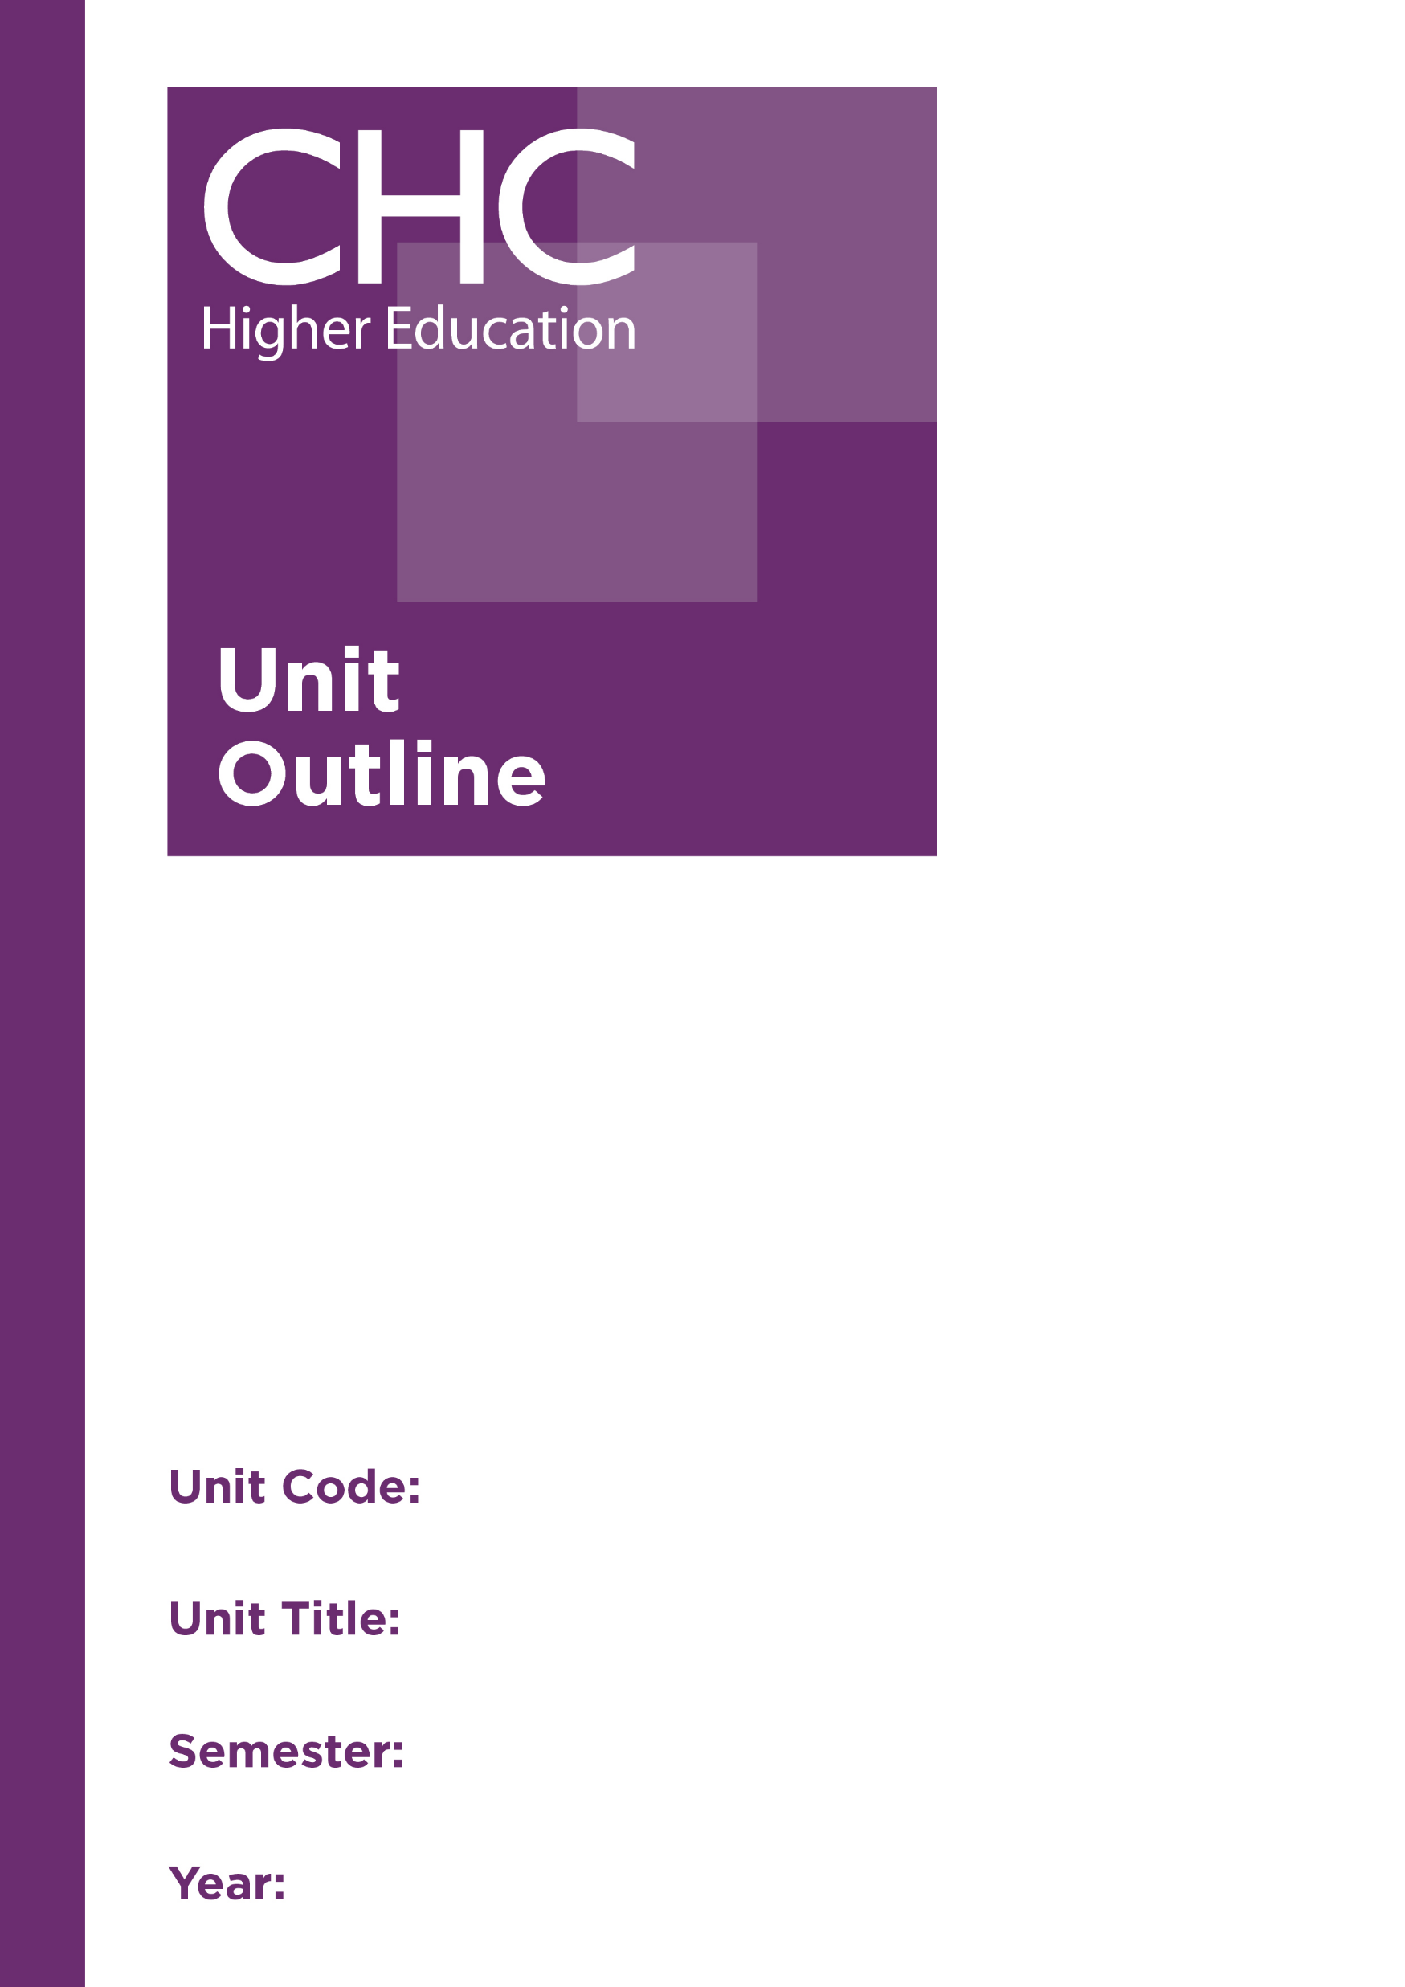
Unit Code: TR541

Unit Title: Trauma Counselling: Intervention
Frameworks

Semester: 1

Year: 2020

Unit code | TR541
Unit name | Trauma Counselling: Intervention Frameworks
Associated higher education awards | Master of Counselling
Duration | One semester
Level | Postgraduate
Unit coordinator | Toni Neil
Core/elective | Elective
Weighting | Unit credit points: 10  Course credit points: 160
Delivery mode | Face-to-face on site
Student workload | Face-to-face on site  Contact hours 35 hours  Reading, study, and preparation 55 hours  Assignment preparation 60 hours  TOTAL 150 hours
 | Students requiring additional English language support are expected to undertake an additional one hour per week.
Prerequisites/ co-requisites/ restrictions | Prerequisite or co-requisite  TR540 Trauma Counselling: Theoretical Foundations  CO614 Processes and Strategies
Rationale | To be able to counsel those who have been affected by trauma, counsellors not only need to understand the nature of trauma and traumatic response, but also specialised skills and strategies are required to work with this particular client group. In this unit, students will be introduced to skills and interventions developed from contemporary and relevant approaches to working with unresolved trauma in order to establish a framework for intervention. The primacy of the therapeutic relationship is also emphasised, and students will have the opportunity to reflect on their use of self in trauma counselling.  Students will evaluate the outcomes of trauma work from a variety of perspectives, including a distinctly Christian worldview, cultural perspectives, ethical and best-practice positions. As part of a holistic framework for intervention, students will also be encouraged to explore the opportunities for developing communities of care for people recovering from unresolved trauma.
Prescribed text(s) | Briere, J., & Scott, C. (2015). Principles of trauma therapy: A guide to symptoms, evaluation and treatment (2nd ed.). Los Angeles, CA: Sage.  Herman, J. (2015). Trauma and recovery: The aftermath of violence-from domestic violence to political terror. New York, NY: Basic Books.
Recommended readings | Books  Courtois, C. (2014). It’s not you, it’s what happened to you [Kindle ebook]. Telemachus Press.  Frewen, P., & Lanius, R. (2015). Healing the traumatised self: Consciousness, neuroscience, treatment. New York, NY: Norton.  Levine, P. (2010). In an unspoken voice: How the body releases trauma and restores goodness. Berkeley, CA: North Atlantic Books.  McMackin, R., Newman, E., Fogler, J., & Keane, T. (Eds.). (2012). Trauma therapy in context: The science and craft of evidence-based practice. Washington, DC: APA.  Ogden, P., & Fisher, J. (2015). Sensorimotor psychotherapy: Interventions for trauma and attachment. New York, NY: Norton.  Rossouw, P. (2014). Neuropsychotherapy: Theoretical underpinnings and clinical appications. Brisbane, Australia: Mediros.  Rothschild, B. (2010). 8 keys to safe trauma recovery: Take-charge strategies to empower your healing. Los Angeles, CA: Norton.  Van der Kolk, B. (2014). The body keeps the score: Brain, mind and body in the healing of trauma. New York, NY: Penguin.  Walker, D., Courtois, C., & Aten, J. (Eds.). (2015). Spiritually oriented psychotherapy for trauma. New York, NY: Norton.  Journals and Periodicals  Developmental Neurobiology  Journal of Child Sexual Abuse  Journal of Interpersonal Violence  Journal of Neuroscience  Journal of Psychology and Theology  Sexual Abuse: A Journal of Research and Treatment  Traumatology  In addition to the resources above, students should have access to a Bible, preferably a modern translation such as The Holy Bible: The New International Version 2011 (NIV 2011) or The Holy Bible: New King James Version (NKJV).  These and others translations may be accessed free on-line at http://www.biblegateway.com. The Bible app from LifeChurch.tv is also available free for smart phones and tablet devices.
Specialist resource requirements | Digital recording device
Content | - A holistic framework for working with trauma  - Assessing unresolved trauma  - Phase-oriented trauma treatment  - The therapeutic relationship and use of self in trauma counselling  - Phase one treatment strategies:  - Establishing safety and trust; containment; grounding; safety plans  - Emotional regulation  - Psycho-education  - Phase two treatment strategies:  - Body-focused approaches  - Cognitive-behavioural approaches  - Experiential approaches  - Phase three – Integration and reconnection:  - Post-traumatic growth  - Developing a community of care for the client  - Cultural, legal, ethical and Christian worldview considerations in working with trauma
Learning outcomes | On completion of this unit, students will have demonstrated that they have:  - applied a bio-psycho-socio-spiritual model to conceptualising, assessing and responding to unresolved trauma;  - developed and reflected on skills and strategies for counselling clients with unresolved trauma;  - critically examined the effectiveness of trauma interventions;  - reflected on the importance of the therapeutic relationship and their use of self in trauma counselling;  - explored community support networks for trauma survivors as part of working collaboratively;  - critically reflected on cultural, Christian worldview, legal and ethical issues relevant to trauma counselling; and  - communicated at an appropriate tertiary standard with special attention to correct grammars, punctuation, spelling, vocabulary, usage, sentence structure, logical relations, style, referencing, and presentation.
Assessment tasks | Task 1: Engagement in class discussion and activities  You are to actively participate in class discussions and activities throughout the semester, demonstrating engagement with the course materials.  Word Length/Duration: N/A  Weighting: 10%  Learning Outcomes: 1,2, 4, 5  Assessed: Weeks 1-13  Task 2: Video and process report  Record a counselling session demonstrating your use of phase 1 trauma techniques. Your conceptualisation and meta-cognition is to be discussed in a process report that analyses the effectiveness of the session and your use of self.  Word Length/Duration: Video - 30 minutes; Process Report - 2,000 words  Weighting: 40%  Learning Outcomes: 1-4, 6, 7  Assessed: Week 9
Task 3: Case study presentation
Analyse a case study, providing a conceptualisation of the trauma issues and an appropriate therapeutic response using one of the approaches studied in this unit. An examination of the approach’s research base, and an analysis of the types of support available for this client in your local region are to be included in the report. This case study is to be presented to the class.
Word Length/Duration: 45 minutes
Weighting: 50%
Learning Outcomes: 1-7
Assessed: Week 15
Unit summary | Students will be introduced to skills and interventions developed from the most current and relevant approaches to working with unresolved trauma in order to establish a framework for intervention. Students will evaluate the outcomes of trauma work from a variety of perspectives, including a distinctly Christian worldview, various cultural perspectives, and relevant ethical and best-practice positions. The use of self, and communities of care will also be explored.

