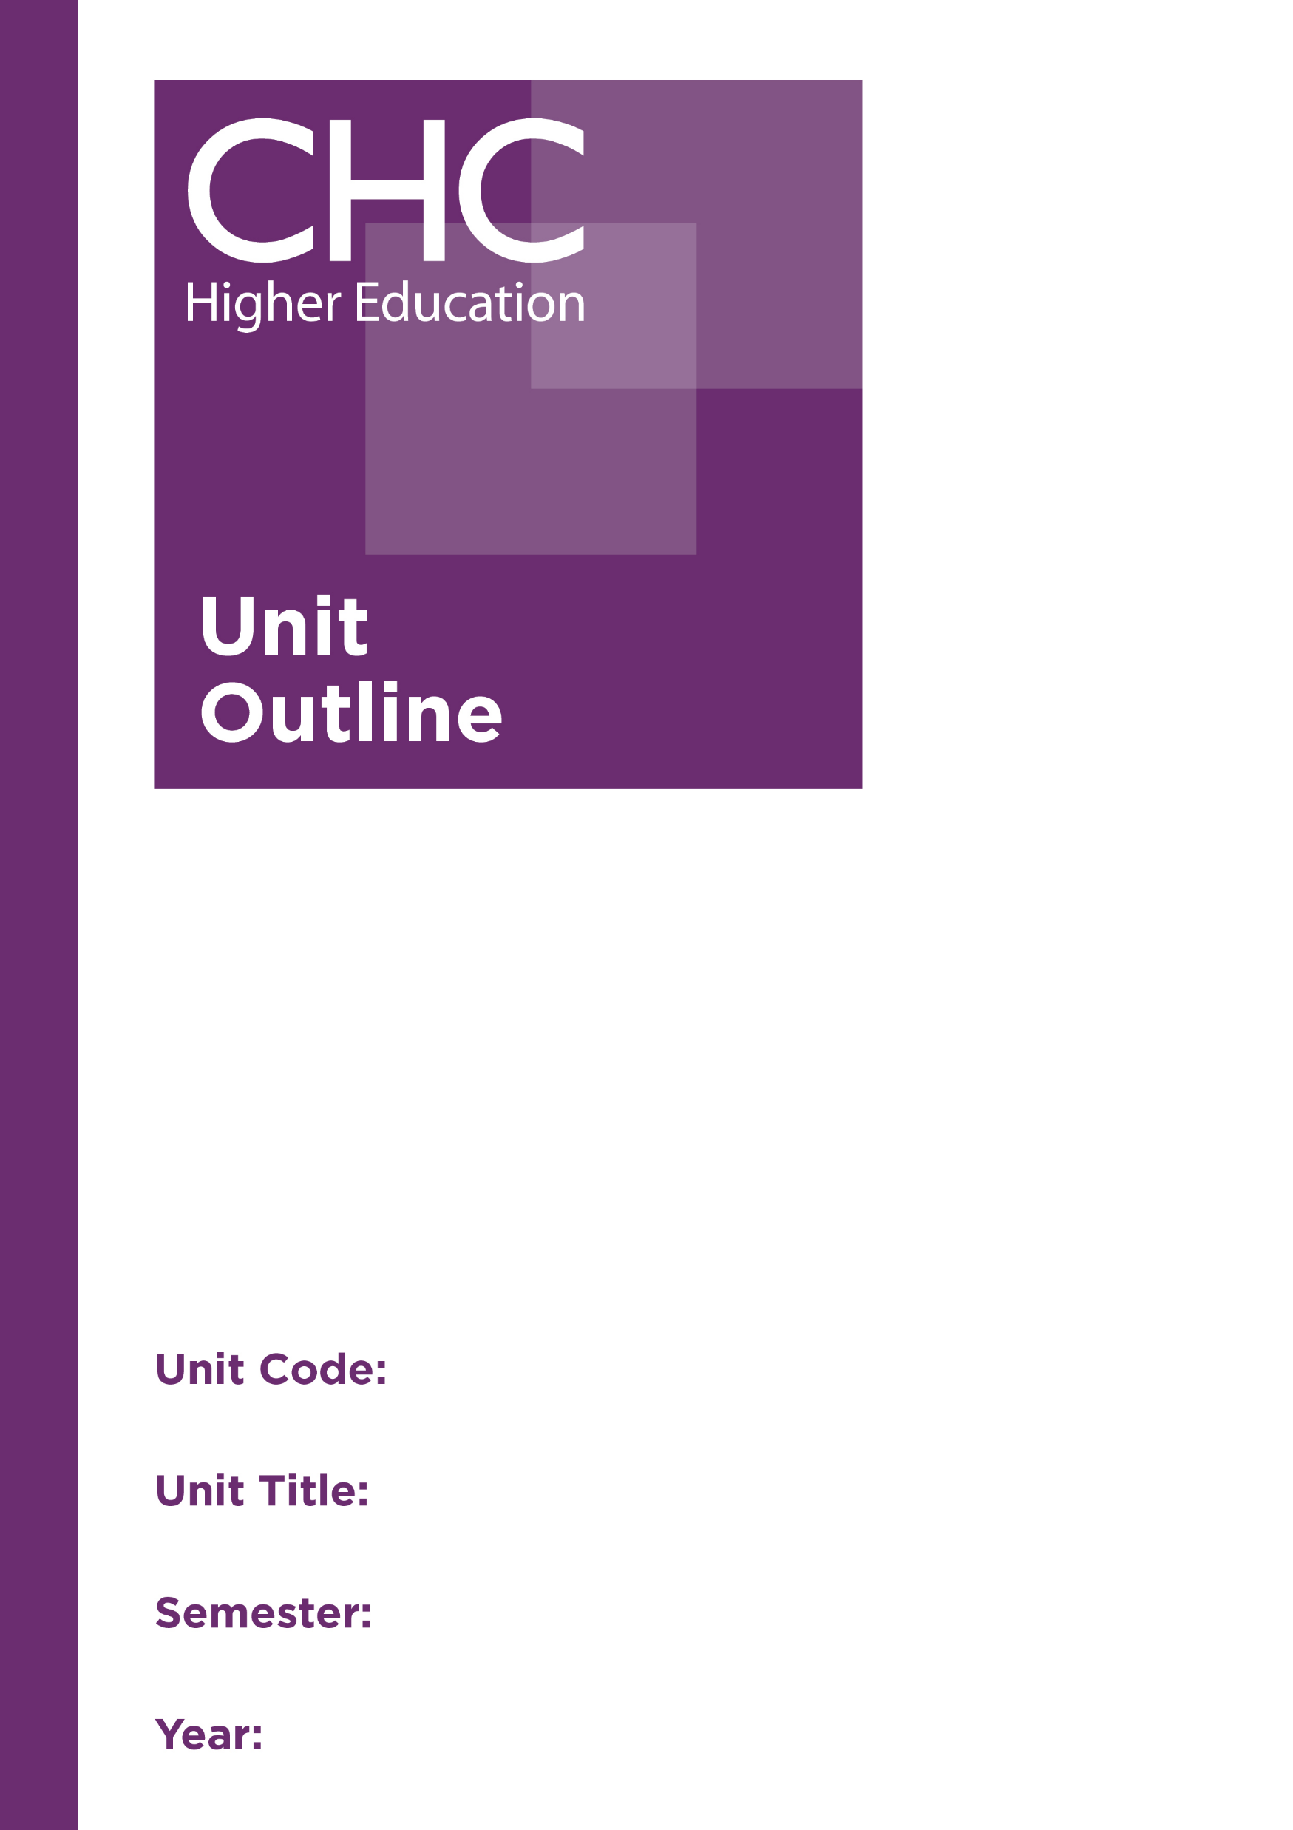
Trauma Counselling: Intervention Strategies
2019

2

TR542

Unit code | TR542
Unit name | Trauma Counselling: Intervention Strategies
Associated higher education awards | Graduate Certificate in Counselling Practice  Master of Counselling Practice  Master of Counselling
Duration | One semester
Level | Postgraduate
Unit coordinator | Dr Carolyn Russell
Core/elective | Elective
Weighting | Unit credit points: 10  Course credit points: Graduate Certificate in Counselling Practice 80  Master of Counselling Practice 120  Master of Counselling 160
Delivery mode | Face-to-face on site
Student workload | Face-to-face on site  Contact hours 35 hours  Reading, study, and preparation 55 hours  Assignment preparation 60 hours  TOTAL 150 hours
 | Students requiring additional English language support are expected to undertake an additional one hour per week.
Prerequisites/ co-requisites/ restrictions | Prerequisite  TR541 Trauma Counselling: Intervention Frameworks  Pre or corequisite  CO667 Reflective Practice: Consolidating Foundations
Rationale | Some trauma presentations are more complex than others, particularly those resulting from trauma experienced in the context of the family. Working with the consequences of trauma experienced in childhood, especially developmental trauma and attachment trauma, requires a more specialised approach than trauma that is less complex.  This unit explores the consequences of combined and cumulative traumas. Students will learn focused intervention strategies for working with clients who have experienced complex trauma and attachment trauma. Mental health professionals have also become increasingly aware of the link between early trauma and later mental health diagnoses. This adds another layer of complexity to trauma counselling as clients often have multiple diagnoses. Students will learn a range of contemporary and research-based interventions for working with these more complex trauma presentations.  This unit will also provide students with the opportunity to reflect on their own experiences of trauma and how that is likely to impact their own work as trauma counsellors. The potential for vicarious traumatisation will be considered, together with the importance of self-care. Emphasis will be given to establishing collaborative practices for trauma work, and developing a holistic framework that considers spiritual, cultural, ethical, and legal perspectives.
Prescribed text(s) | Courtois, C., & Ford, J. (2016). Treatment of complex trauma: A sequenced, relationship-based approach. New York, NY: Guilford.  Langberg, D. (2015). Suffering and the heart of God: How trauma destrys and Christ restores. Greensboro, NC: New Growth Press.
Recommended readings | Books  Allen, J. (2013). Restoring mentalizing in attachment relationships: Treating trauma with plain old therapy. Washington, DC: American Psychiatric Publishing.  Boon, S., & Steel, K. (2011). Coping with trauma-related dissociation: Skills training for patients and therapists. New York, NY: Norton.  Courtois, C. & Ford, J. (Eds.). (2013). Treating complex traumatic stress disorders: Scientific foundations and therapeutic models. New York, NY: Guilford.  Frewen, P., & Lanius, R. (2015). Healing the traumatised self: Consciousness, neuroscience, treatment. New York, NY: Norton.  Gingrich, H. (2013). Restoring the shattered self: A Christian counselor’s guide to complex trauma. Westmont, IL: InterVarsity Press.  Kezelman, C., & Stavropoulos, P. (2012). The last frontier: Practice guidelines for treatment of complex trauma and trauma informed care and service delivery. Sydney, Australia: ASCA.  Matheiu, F. (2012). The compassion fatigue workbook: Creative tools for transforming compassion fatigue and vicarious traumatization. New York, NY: Routledge.  Meares, R. (2012). A dissociation model of borderline personality disorder. New York, NY: Norton.  Ogden, P., & Fisher, J. (2015). Sensorimotor psychotherapy: Interventions for trauma and attachment. New York, NY: Norton  Ross, C., & Halpen, N. (2009). Trauma model therapy: A treatment approach for trauma dissociation and complex comorbidity. Richardson, TX: Manitou Communications.  Walker, D., Courtois, C., & Aten, J. (Eds.). (2015). Spiritually oriented psychotherapy for trauma. New York, NY: Norton.  Journals and Periodicals  Developmental Neurobiology  Journal of Child Sexual Abuse  Journal of Interpersonal Violence  Journal of Neuroscience  Journal of Psychology and Theology  Sexual Abuse: A Journal of Research and Treatment  Traumatology  In addition to the resources above, students should have access to a Bible, preferably a modern translation such as The Holy Bible: The New International Version 2011 (NIV 2011) or The Holy Bible: New King James Version (NKJV).  These and other translations may be accessed free on-line at http://www.biblegateway.com. The Bible app from LifeChurch.tv is also available free for smart phones and tablet devices.
Specialist resource requirements
Content | - Revisiting complex trauma and attachment trauma  - Trauma-informed principles of practice  - Clarifying goals and the counsellor’s role as part of a broader support team  - Strategies for working with traumatic attachment  - Strategies for working with a shame-based identity  - Strategies for working with trauma-related dissociation  - Trauma as an underlying factor in other mental health diagnoses  - Spiritual dimensions of trauma  - Vicarious trauma and self-care for the therapist
Learning outcomes | On completion of this unit, students will have demonstrated that they have:  - applied a bio-psycho-socio-spiritual model to conceptualising, assessing and responding to complex trauma and relational trauma;  - developed and reflected on specific skills and interventions for counselling clients with complex trauma and relational trauma;  - critically analysed the effectiveness of specific interventions for use with complex trauma and relational trauma;  - critically reflected on their own experiences of trauma and its influence on their use of self in counselling, the potential for vicarious traumatisation and the importance of self-care;  - synthesised their knowledge, understanding and skills for conceptualising, assessing and counselling clients with unresolved trauma;  - critically discerned the spiritual dimensions of trauma and trauma counselling; and  - communicated at an appropriate tertiary standard with special attention to correct grammars, punctuation, spelling, vocabulary, usage, sentence structure, logical relations, style, referencing, and presentation.
Assessment tasks | Task 1: Reflective essay  Reflect on your own experiences of trauma and how these may impact your work as a trauma counsellor. A consideration of the potential for vicarious traumatisation and the importance of self-care is to be included.  Word Length/Duration: 1500 words  Weighting: 25%  Learning Outcomes: 1, 4, 6, 7  Assessed: Week 7  Task 2: Media presentation  Research an area of interest related to one specific type of complex trauma. The presentation is to include a discussion of theoretical understandings, prevalence, causative factors, effects, and evidence-based counselling interventions. This is to be presented to the class in the form of a media presentation.  A 1-2 page handout for the class that outlines the main points of your presentation is to be included.  Word Length/Duration: 30 minutes; Handout: 1000 words  Weighting: 35%  Learning Outcomes: 1,3 6, 7  Assessed: Week 10  Task 3: Case study report  Write up a case study report of your work with a client you have been working with on your practicum, demonstrating your ability to work with someone who has experienced some form of relational trauma. The report is to include a case formulation, a description of the therapeutic approach, interventions and referral processes you have used with the client, a consideration of any ethical and/or legal issues inherent in the case, and a reflection on the progress of your work with this client  Word Length/Duration: 2,500 words  Weighting: 40%  Learning Outcomes: 1-7  Assessed: Week 15
Unit summary | This unit gives students a range of skills and contemporary and research-based interventions for working with more complex trauma issues that come from the effects of combined and cumulative traumas, as well as clients with multiple diagnoses. This unit also considers the student’s own experience of trauma, the potential for vicarious traumatisation and the importance of self-care. Emphasis will be given to establishing collaborative practices for trauma work, and developing a holistic framework that considers spiritual, cultural, ethical, and legal perspectives.

